TestReady Software
Operation Manual
（V2.0）

CONTENT
1.0 Foreword 1
2.0 Version & Alarm 2
2.1.0 Version No. 2
2.2.0 Copyright 2
2.3.0 Alarm & Attention 2
3.0 Contacts 2
4.0 Software installation 3
4.1.0 PC System requirements 3
4.1.1.0 Requirements 3
4.2.0 Installation 3
5.0 Overview 3
5.1.0 Software startup 3
5.2.0 Software exit 3
5.3.0 Main Interface 4
5.3.1.0 Main function menu 4
5.3.2.0 Sensor indication 5
5.3.3.0 Speed control bar 5
5.3.4.0 Toolbar 6
5.3.5.0 Function tab 6
5.4.0 Introduction to Main View Tab 7
5.5.0 Introduction to Test View Tab 7
5.6.0 Introduction to Scheme Settings Tab 9
5.6.1.0 Scheme Settings Tab - Basic Parameters 10
5.6.2.0 Scheme Settings Tab - Sampling/Data Channels 11
5.6.3.0 Scheme Settings Tab - Input/User Parameters 12
5.6.4.0 Scheme Settings Tab - Calculation Parameters 14
5.6.5.0 Scheme Settings Tab - Output/Result Parameters 15
5.6.6.0 Scheme Settings Tab - Testing Process 16
6.0 How to create a new test 22
7.0 How to edit test templates 22
7.1.0 Open existing template directly for editing 22
7.2.0 Export from existing experimental data 23
7.3.0 How to edit a new template 23
8.1.0 Equipment Para.---Host 26
8.2.0 Equipment Para.---Input & Output 27
8.3.0 Equipment Para.---Deformation measurement serial port chart(Micro meters) 28
8.4.0 Equipment Para.---Temp Controller 29
8.5.0 Equipment Para.---Auto-Extensometer 30
8.6.0 Equipment Para.---Video Extensometer 34
8.7.0 Equipment Para.---Strain Gauge 34
9.0 How to modify software option settings 35
10.0 How to set sensor（MGC） 38
11.0 How to identify the direction of sensors (MGC) 40
12.0 How to set controller parameters (MGC) 41
13.0 How to calibrate and verify sensors (MGC) 43
13.1.0 Calibration and verification of load cell 43
13.2.0 Calibration and verification of extensometer 44
13.3.0 Calibration and verification of displacement 44
14.0 How to use the control debugger (MGC) 45
15.0 FAQ 46
16.0 Appendix 48

1.0 Foreword
Thank you for your trust in our products!
Please pay special attention to the areas marked with "★" in this manual and read them carefully.
★Attention:
Our company owns all independent intellectual property rights of the software described in this manual. Without written authorization from our company, no unit or individual may extract, copy, or imitate the content, images, or tables for other profit-making purposes. Otherwise, our company will consider it an infringement and reserves the right to take further measures.
★Attention:
Due to the different models ordered by different users, their usage methods and execution standards also vary greatly. Our company does not guarantee that every user's software includes all the functions in this manual. We also do not guarantee that every user's software will be exactly the same as the content in this manual.
★Attention:
This manual was compiled based on the software developed at the time of publication. With the continuous upgrading of the software, there may be discrepancies between the software and the content in the manual. Any modifications will not be notified separately. Thank you for your understanding!
★Special statement:
This manual cannot serve as a basis for making any requests to our company. The interpretation of this manual belongs to our company.
★Solemn declaration:
The testing machine is a precision equipment, please read this manual carefully before use. Special attention should be paid to installing limit protection devices before each use or replacement of fixtures to prevent damage to sensors, fixtures, and other components caused by operational errors. Our company will not be held responsible for any problems caused by human operation issues.
★After sales service:
If you encounter any difficulties or equipment malfunctions during the use of the device, you can quickly contact our company or distributor.

2.0 Version & Alarm

2.1.0 Version No.
1.3.20250627

2.2.0 Copyright

Copyright @SINOTEST Equipment (Jiangsu) Co., Ltd. Maintain all rights and interpretation.

2.3.0 Alarm & Attention
The operation of the testing machine carries certain risks. Therefore, before conducting the experiment, it is necessary to read and understand the relevant safety signs.
 | There is high voltage inside the machine. Non professionals are not allowed to open it by themselves.
 | Electrical alarm: Please disconnect the power supply before opening the door of the distribution box. Please disconnect the power supply of the equipment before removing any electrical protection devices or replacing fuses. Do not reconnect the power supply when removing the protective device. Reinstall the protective device as soon as possible.
 | Warning of pinch injury: When gripping the sample, hands must be kept away from the gripping area to prevent finger injury.

3.0 Contacts
If you encounter any problems or equipment malfunctions during use, please contact SINOTEST and we will provide you with answers as quickly as possible.
SINOTEST EQUIPMENT (JIANGSU) CO.,LTD SINOTEST EQUIPMENT CO.,LTD
TEL：+86 0510-68791668 TEL：+86 0431-85175108
HOTLINE： 400-965-1118 Web：www.ccss.com.cn

4.0 Software installation

4.1.0 PC System requirements

4.1.1.0 Requirements
- Hardware requirements
Processor (CPU): such as "Intel Core i5 or higher, AMD Ryzen 5 or higher".
Memory (RAM): Minimum 8GB, recommended 16GB+.
Storage (hard drive/SSD): installation required space (such as 500MB) and temporary space required for operation (such as recommended to reserve more than 10GB).
Graphics card/monitor: graphics processing requirements (such as video memory, resolution, suitable for design/visualization software).
Other peripherals: optional devices (such as printers, encryption dongles, specific sensors, etc.).
- Software requirements
Operating system: Supported system versions (such as "Windows 10/11 64 bit").
Office software: Office2013 and above versions
Network environment: Network activation and online functions (such as "network verification license required for first use")

4.2.0 Installation
The software has good compatibility and is easy to install and uninstall. Follow the normal installation and uninstallation steps. After installation, the software desktop shortcut will appear on the desktop.

5.0 Overview

5.1.0 Software startup
Double click the shortcut 【TestReady. exe】 on the desktop to start the software.
Note: After the software is decompressed, send the file TestReady.exe to the desktop in the decompressed directory to generate a shortcut.

5.2.0 Software exit
Click the button in the upper right corner of the software interface directly.

5.3.0 Main Interface
The main interface of the software is displayed as shown in the following figure:
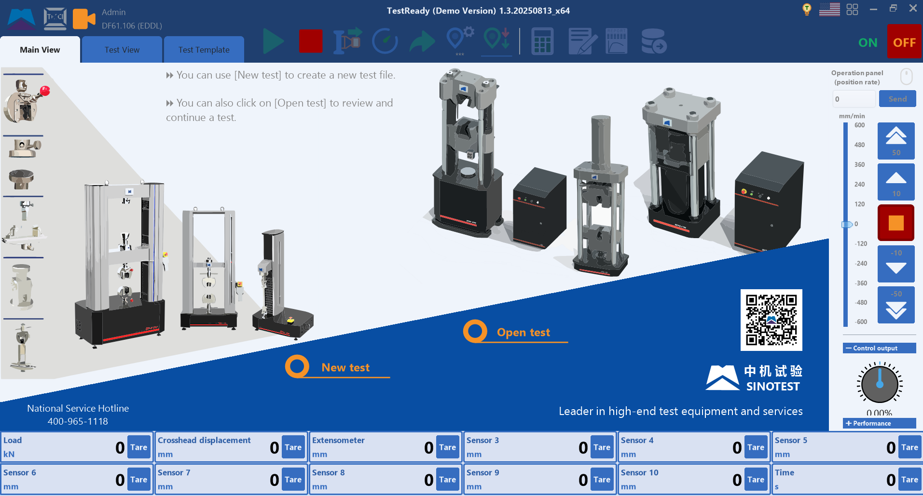

5.3.1.0 Main function menu
 Specifically divided into: editing test templates, exporting test templates, equipment types and controllers, equipment parameters, changing passwords, and option settings.

Options | Function description | Remarks
Edit test template | Edit the template to be used for testing
Export test template | Export the current test template or test data as a new test template
Equipment type & controller (demo) | Select relevant equipment and controllers
Equipment para. | Set relevant parameters
Changing password | Change password
Option settings | Modify the default settings, preset speed, and ‘return to origin point’ settings
 The language bar can modify 3 languages: 

5.3.2.0 Sensor indication
Used to display the current sensor reading. Right click can reset the zero point.

5.3.3.0 Speed control bar
Speed display, control buttons, and commands.
Illustration | Function description | Remarks
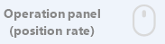 | After clicking unlock, you can use the mouse wheel to change the speed
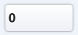 | Input for controlling speed
 | Send the input value to the controller
 | Quickly Up button.The increase in value varies depending on the selected control method
 | Slowly Up button. The increase in value varies depending on the selected control method
 | Test/Run Stop Button
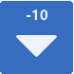 | Slowly Down button. The increase in value varies depending on the selected control method
 | Quickly Down button.The increase in value varies depending on the selected control method
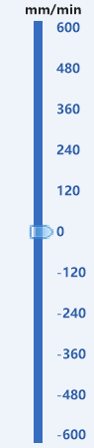 | Slide bar: drag to send numerical values directly to the controller
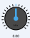 | Output indicator for control commands
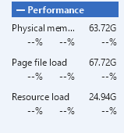 | Monitor the current system performance. When the threshold is reached, a prompt will be triggered

5.3.4.0 Toolbar

Illustration | Function description | Remarks
 | Run a test
 | Test/ Operation stop
 | Extensometer switch | When calculating deformation/selecting a combination of deformations, it can be used
 | Modify the movement speed of the crossbeam in the test
 | Go to next step
 | Set the origin of displacement (needs to be reset after restarting the software)
 | Return the origin of the displacement (the return time is set in 'Function Menu ->Options')
 | Save the current selection and recalculate the experimental data
 | Edit test report templates, such as modifying fonts, formatting, etc
 | View the test report, which can be printed or exported in Word format
 | Export sampling data (‘.xlsx’, ‘.csv’ files)
 | Turn on UTM
 | Turn off UTM

5.3.5.0 Function tab
The functional tabs of the software are divided into: main view, test view, and template settings.

5.4.0 Introduction to Main View Tab
As shown below:

- New test: Create a new test from a test template.
- Open test: Open tests that have already been conducted.

5.5.0 Introduction to Test View Tab
As shown below:
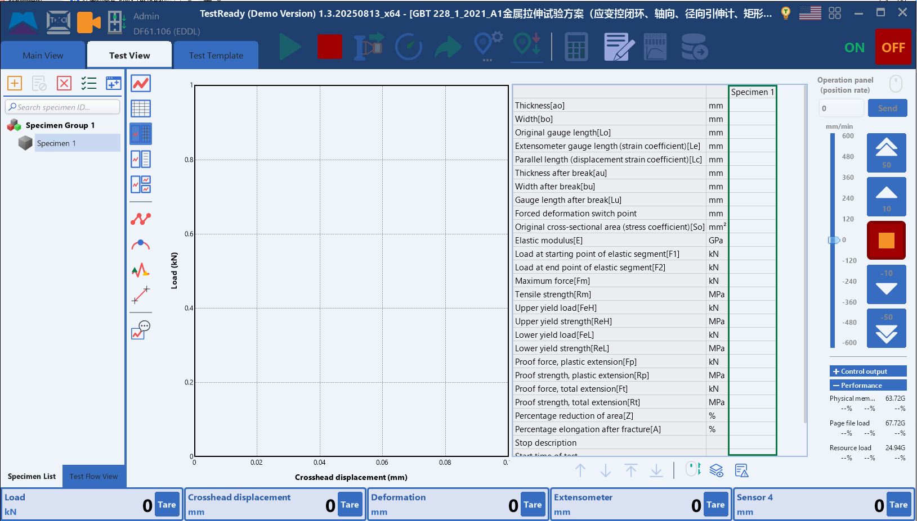
- Specimen list: Display all completed and unfinished samples.
- Process View: Display the control steps of the test plan and the current control steps during the test running.
- Coordinate switching: Right click on the left or bottom coordinate values to bring up a menu where you can select the type of curve to display.
- Display main curve: , Only display the main curve graph.
- Display result bar: 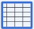, Only display the test results.
- Display main curve & result bar: 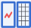Simultaneously display.
- Display the main curve and test log records:  Simultaneously display.
- Multi curve display: 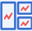, Simultaneously display three curves.
- Mark sampled points: 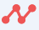, Display the sampled points on the curve.
- Mark feature points: , Mark the sampled feature points on the curve, such as max. force.
- Mark switching point: 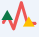, Mark starting and ending points of each control segment on the curve.
- Select two points to calculate speed: 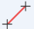, Select 2 points on the curve to calculate loading speed of the current control segment.
- Curve operation help:  After clicking, the operation instructions for the curve will be displayed.
- Move up 1 line and select parameter line: 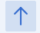Need to first select the entire row of parameters.
- Move down 1 line and select parameter line: Need to first select the entire row of parameters.
- Top the selected parameter row:  Need to first select the entire row of parameters.
- Bottom the selected parameter row: Need to first select the entire row of parameters.
- Select the direction of roller movement: 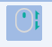 When both horizontal and vertical scrollbars are present, determine which direction the scroll wheel is used for. (Default is up and down, click to switch)
- Display all parameters: Display all parameters, including those that have been calculated and exist in the database but have not been selected in the plan.
- List of failed calculation errors:  The results of calculation failure will be displayed in this list.
- New sample:  Add a new sample in this list.
- Abolish:  Abolish the currently selected tested sample and run it again.
- Delete:  Delete currently selected sample.
- Multiple choose: 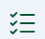 After clicking, it will enter the sample multi selection mode.
- Batch input:  Click to enter the dialog box for batch input of samples.

5.6.0 Introduction to Scheme Settings Tab
As shown below:
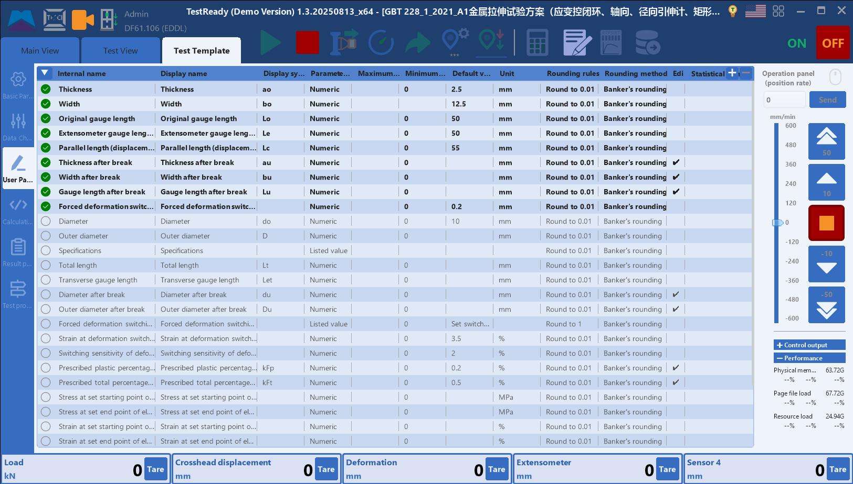

- Basic para.: Basic information of the test plan, such as test standard selection, strain channel, test space, and coordinate settings.
- Sampling/ Data channel: Set the current required sampling channels, such as force, displacement, customization, etc., mainly refer to the channel manual.
- Input/ User para.: Set the parameter values that need to be input before or after the test.
- Calculation para: Set some parameters that need to be calculated at the beginning of the test, such as the original cross-sectional area.
- Output/ Result para.: Set some parameters that need to be calculated after the test ends, such as maximum force.
- Test process: Set the control steps for the current test template during testing.

5.6.1.0 Scheme Settings Tab - Basic Parameters
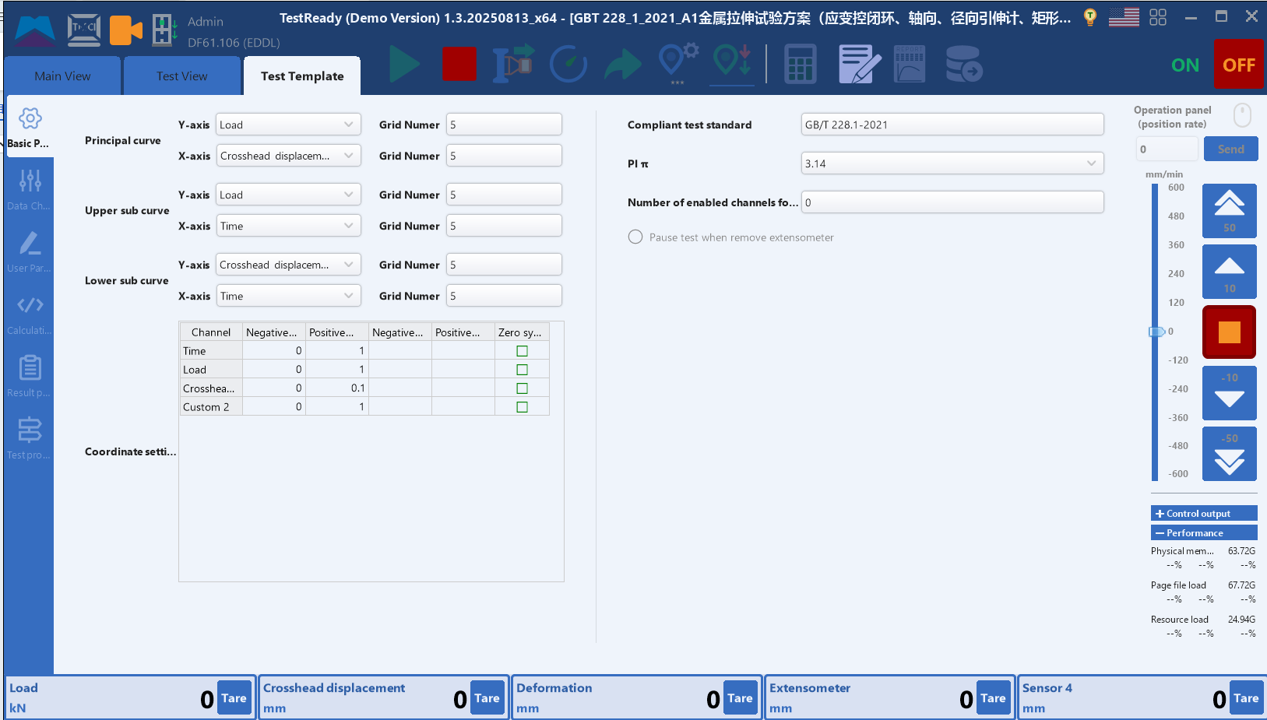

- Compliant test standards: Serial number of test standard
- PI Π：Confirm the Π value
- Curve parameters: The selection of X/Y axes and the setting of upper and lower limits for the three curves.
- Number of channels for strain gauges: When Enable strain gauge, we can select channel.
- Remove extensometer & pause: Pause the test when removing extensometer, select as needed.
- Use the testing space on the other side: Used to modify current test space selection.

5.6.2.0 Scheme Settings Tab - Sampling/Data Channels
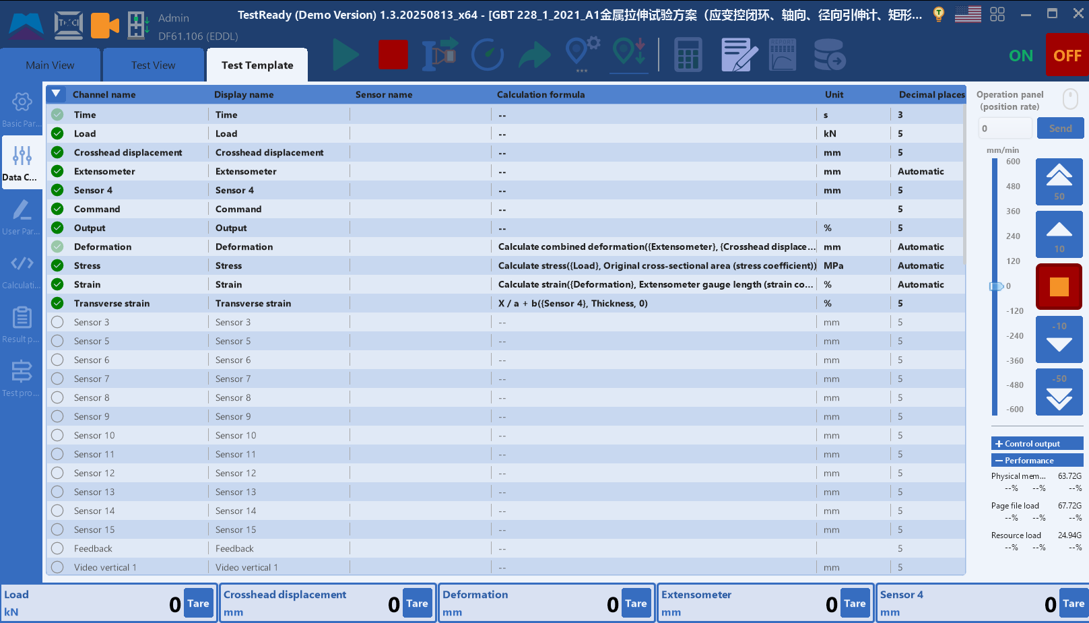
Set the sampling channels required for the current test, such as force, displacement, etc.
After selecting, you can choose from the parameter value options table. Icon：
We can modify channel’s (such as deformations):
Displayed name (Icon：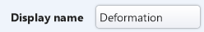)
Units (Icon: 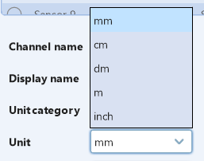)
Decimal point (Icon：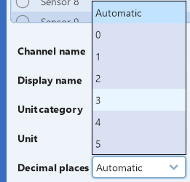)
Calculation formula (Icon：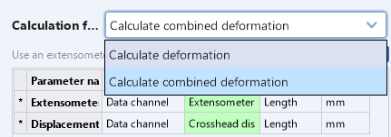)
Optional parameters: 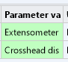 After clicking, select required parameters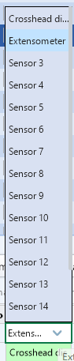.

5.6.3.0 Scheme Settings Tab - Input/User Parameters

Input/ User para.: Set the values that need to be input before or after the current test template.
After selecting, you can choose from the parameter value options table.
We can modify channel’s (such as sample diameter):
Displayed name (Icon: 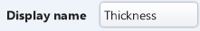)
Displayed symbol (Icon: 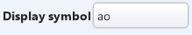)
Units (Icon: 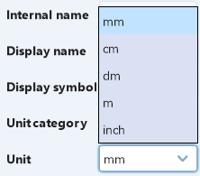)
Default value (Icon :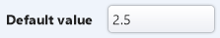)
Input upper/max. limit (Icon :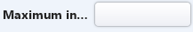)
Input lower/min. limit (Icon :)
Rules of rounding (Icon :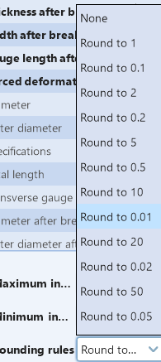)
Methods of rounding (Icon :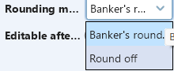)
Determine whether modifications can be made after test (Icon :)

5.6.4.0 Scheme Settings Tab - Calculation Parameters
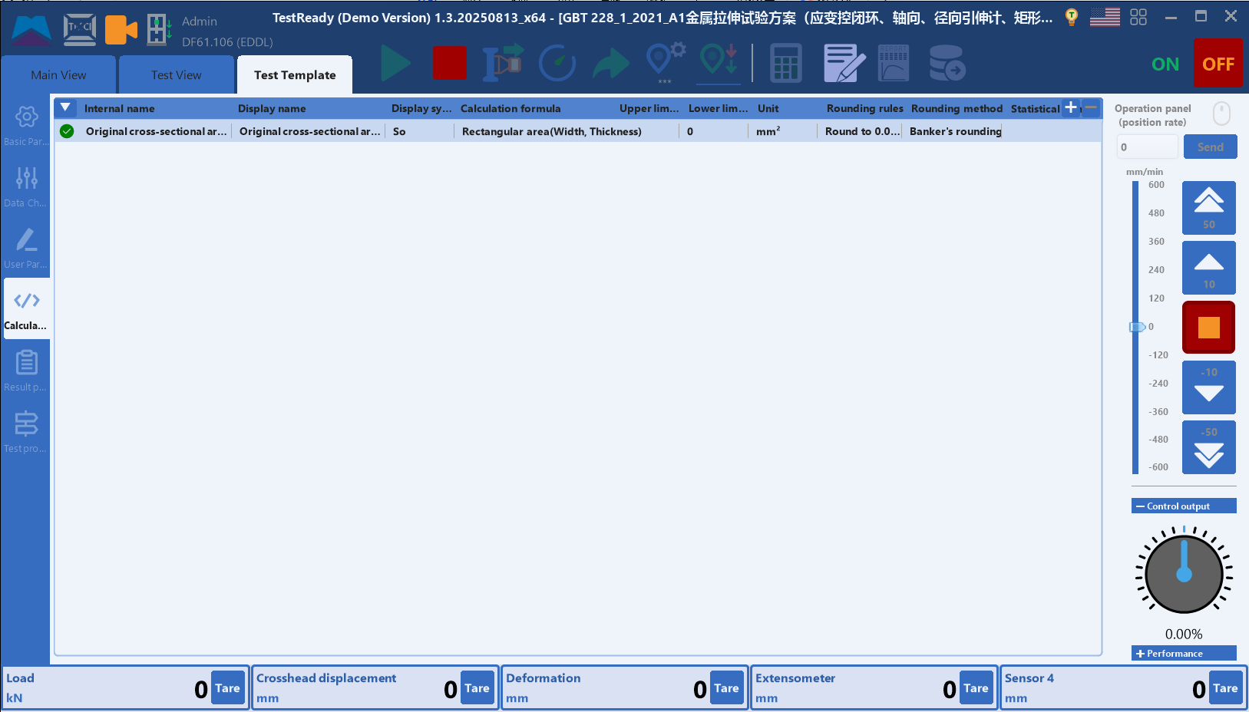

Set some parameters that need to be calculated at the beginning of the current test, such as the original cross-sectional area, and confirm the optional options in the template.
After selecting, you can choose from the parameter value options table:
We can modify parameters’ (such as original cross-sectional area):
Displayed name (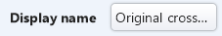)
Displayed symbol (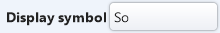)
Units (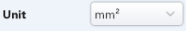)
Upper limit of evaluation (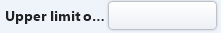)
Lower limit of evaluation (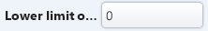)
Rules of rounding (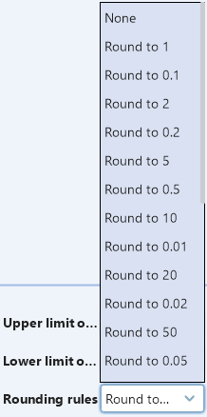)
Methods of rounding (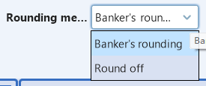)

5.6.5.0 Scheme Settings Tab - Output/Result Parameters
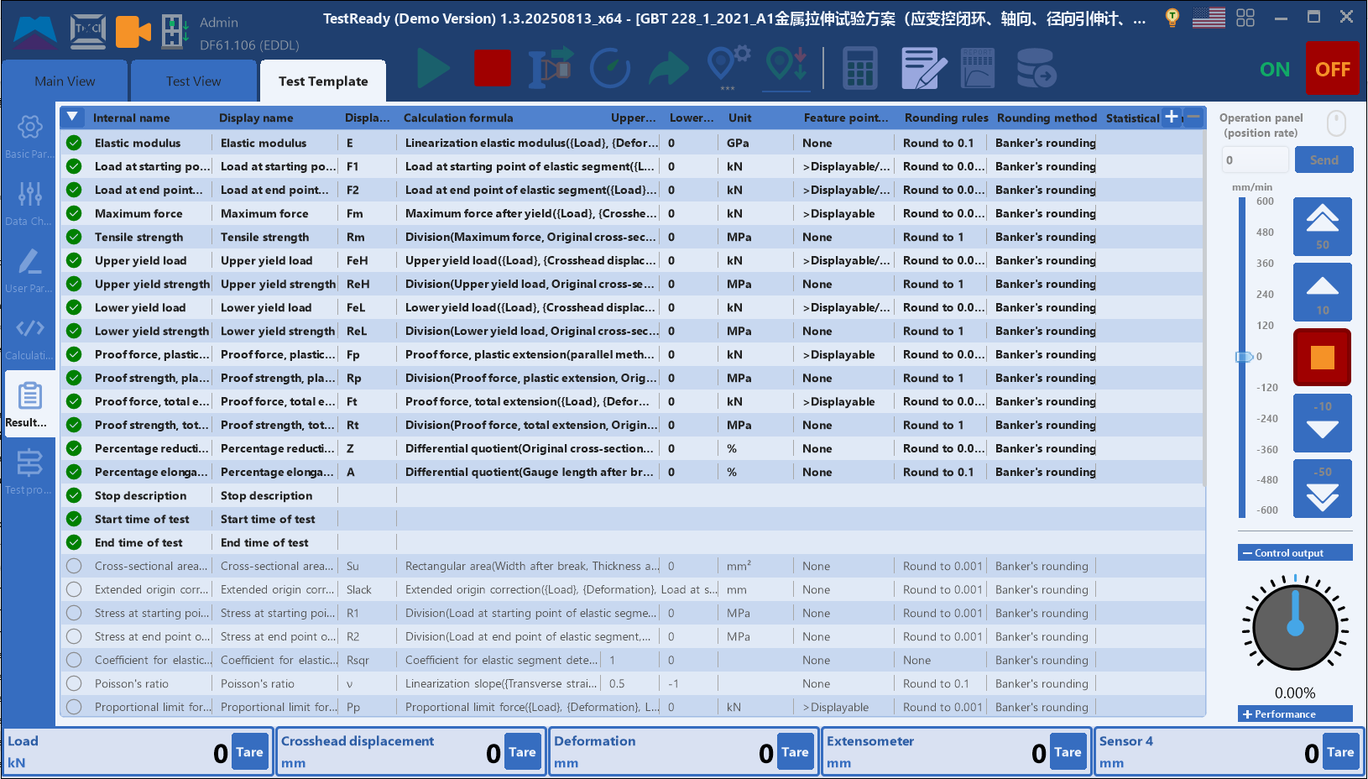
Set parameters that need to be calculated after the current test finishes, such as maximum force.
After selecting, you can choose from the parameter value options table.
We can modify parameters’ (such as elastic modulus):
Displayed name (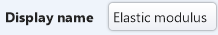)
Displayed symbol ()
Units (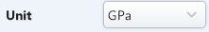)
Upper limit of evaluation ()
Lower limit of evaluation (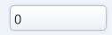)
Rules of rounding (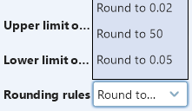)
Methods of rounding (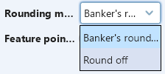)
Feature point display (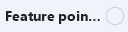)

5.6.6.0 Scheme Settings Tab - Testing Process
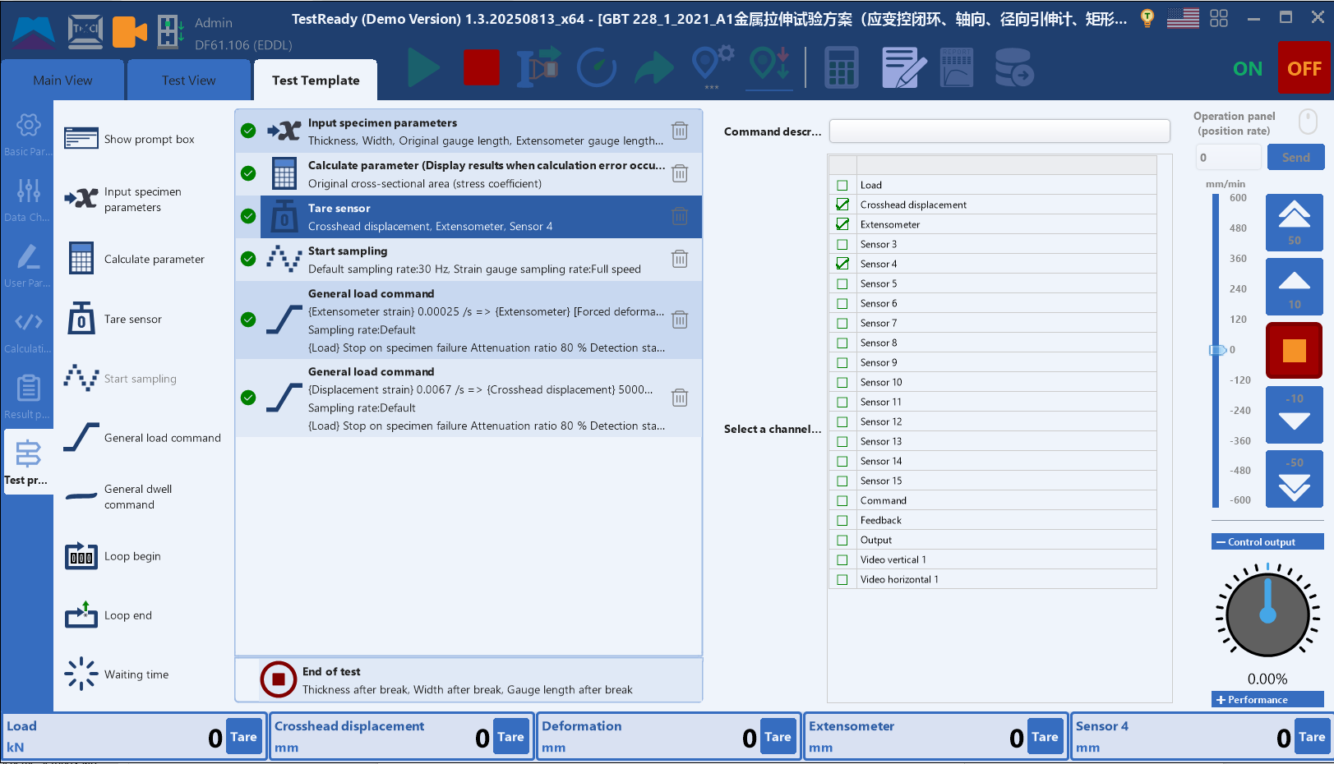

Set the control steps for the current experiment by dragging the steps on the left to the right for process design.
- Display prompt box（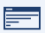）：Set command description and prompt content. After clicking OK, proceed to the next step. It is generally not used during the experimental process.
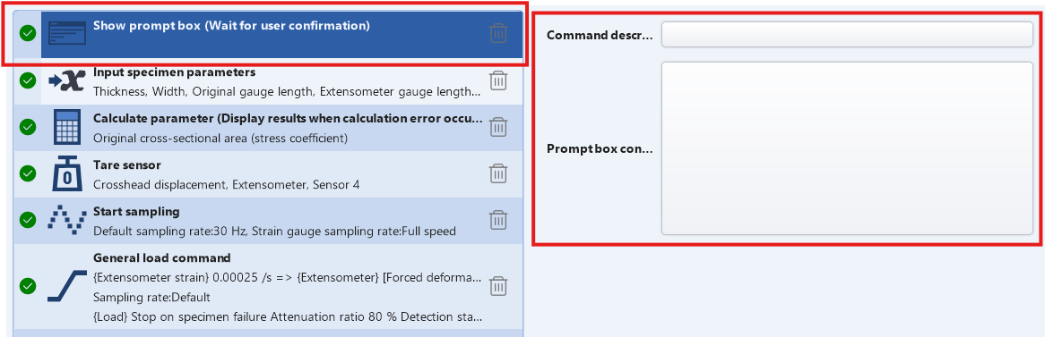
- Input sample para.（）：Select input parameters (the options are the input parameters previously selected in the scheme settings tab), and enter a command description.
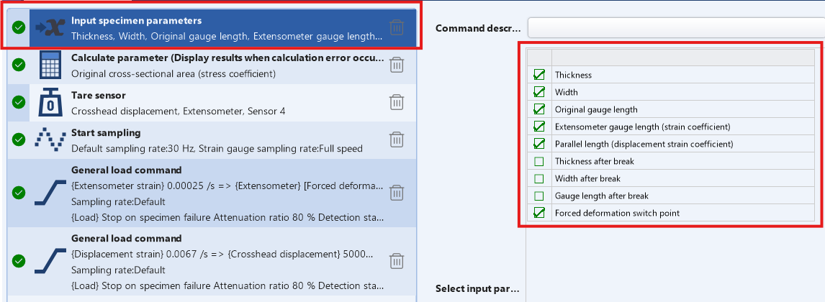
- Calculate para.（）：Select the parameters to be calculated (optional are the calculation parameters previously selected in the scheme settings tab), enter the command description, and preview the calculation results (prompt when there are errors in the calculation or always preview and confirm).
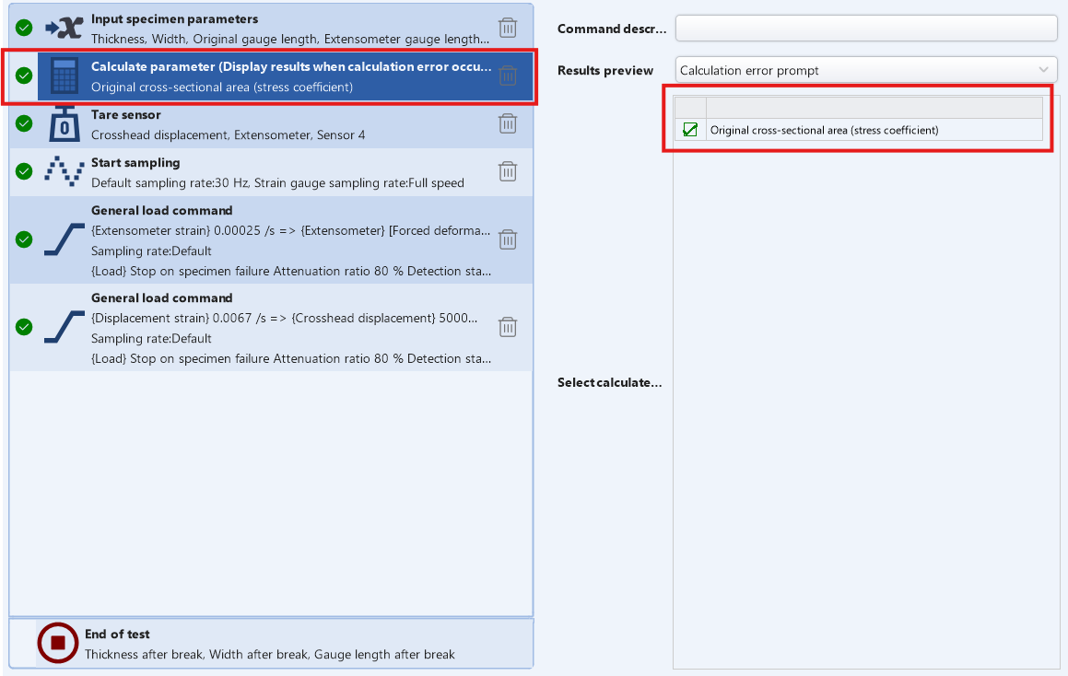
- Sensor clear（）：Select the channel to be cleared from the channel list and enter command description.
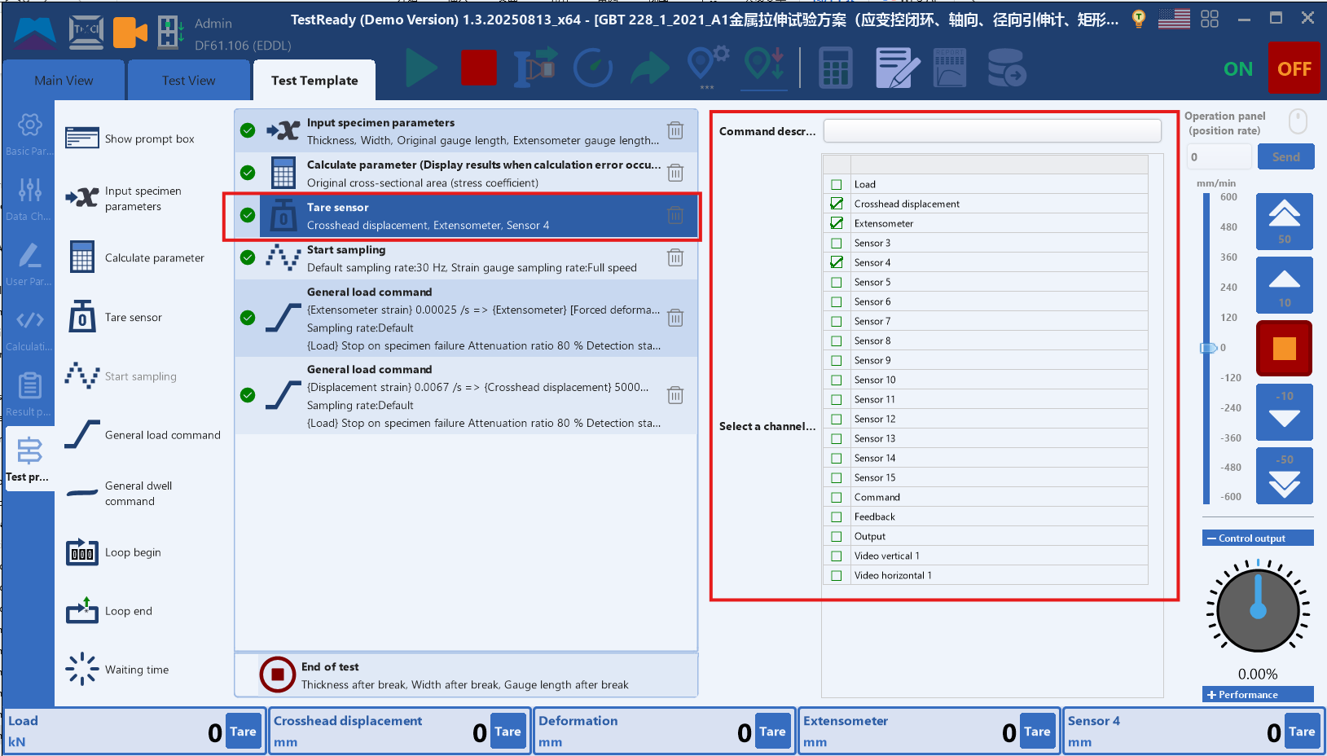
- Start sampling（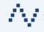）：Select sampling rate (cannot be modified when selected as full speed); Enter command description. (Sampling usually starts after the sensor is cleared)
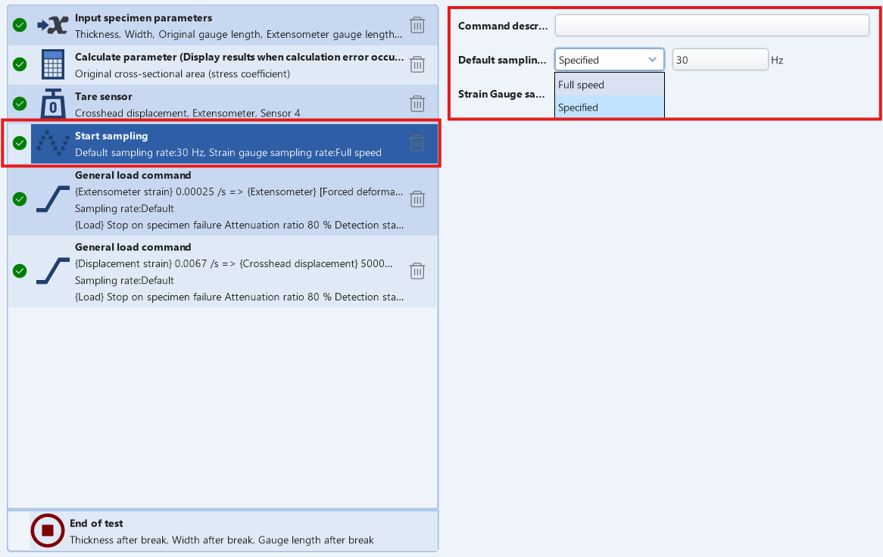

- General loading command（）：You can choose whether to perform upper limit detection, lower limit detection, and fracture detection; Select control parameters and target parameters; Control parameters and target parameters can be arranged and combined. Select the sampling rate (default is 30Hz), enter the command identifier (mainly used for channel lookup, especially for loop commands), and enter the command description. When a predetermined target is detected or loaded, the experiment can be stopped or moved to the next step.（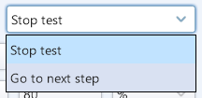）
- Unique loading command - Target parameter: Control machine to run to target parameter.
- Upper limit detection: Priority detection item, to check whether the selected parameter has reached the upper limit value.
- Lower limit detection: The second test item to check whether the selected parameter has reached the lower limit value.
- Fracture detection - starting value for detection: When the current force value is greater than the set value, the following two conditions are used to determine fracture. If one of the two conditions is met, it is judged as fracture. Mainly used to avoid misjudgment of fracture caused by unstable force during the initial stage of the test.
- Fracture detection - fracture attenuation rate: When (Max Min)/Max>set value, judged as fracture.
- Fracture Detection - Lower Limit of Fracture: If the maximum force value is greater than the set value and the current force value is less than the set value, it is judged as fracture.
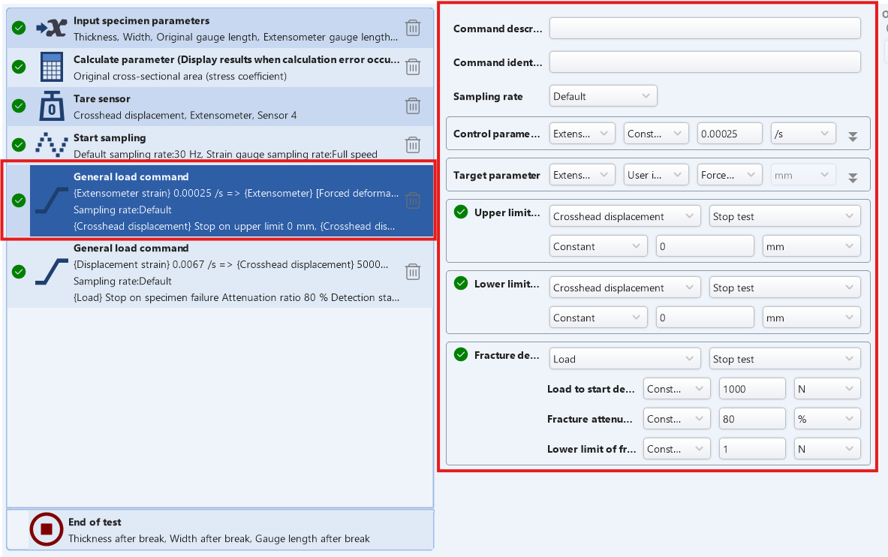
- General holding command（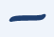）：You can choose whether to perform upper limit detection, lower limit detection, and fracture detection, select control parameters and target parameters, select sampling rate (default is 30Hz), enter command identifier, and enter command description. When the predetermined target is detected or after maintaining the predetermined time, the experiment can be stopped or moved to the next step.（）
Unique Holding command - hold time: The time or other variables that the control device maintains under control parameters (usually triggering detection conditions before reaching the target time).
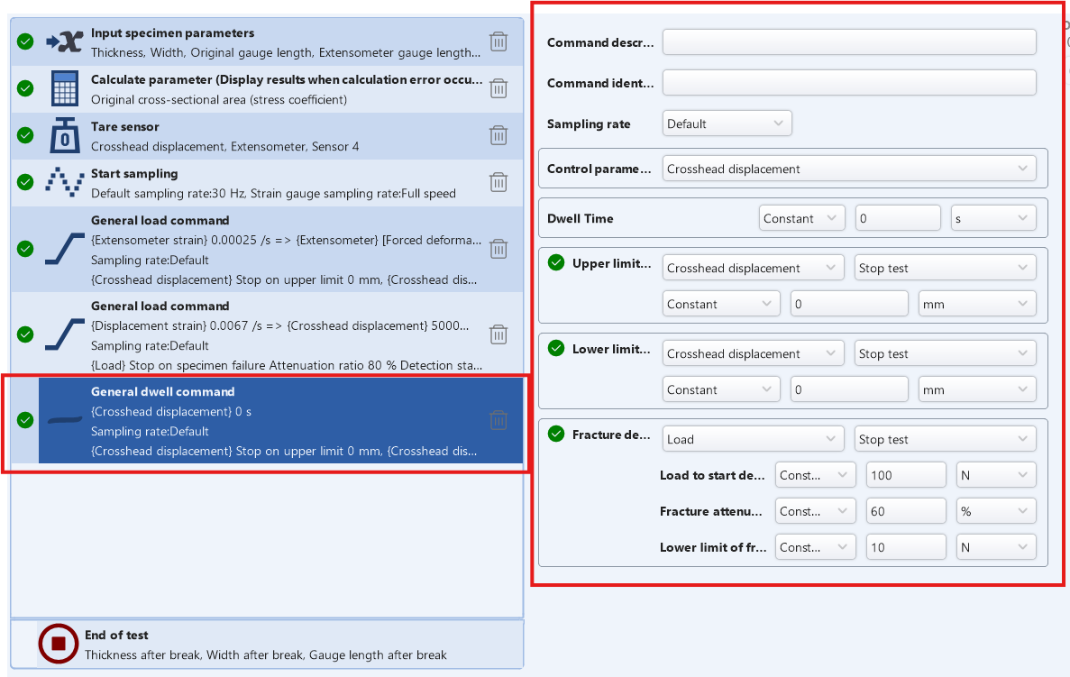

- Loop start（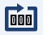）：Beginning of the loop, you can set the number of loops and input a command description.

- Loop end（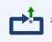）：End of the loop, you can be described by entering a command.
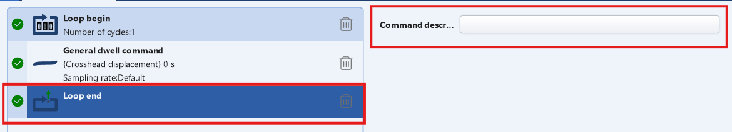

- Waiting time（）：Set how long to wait.
Unique waiting time - waiting time：Target time of how long to wait

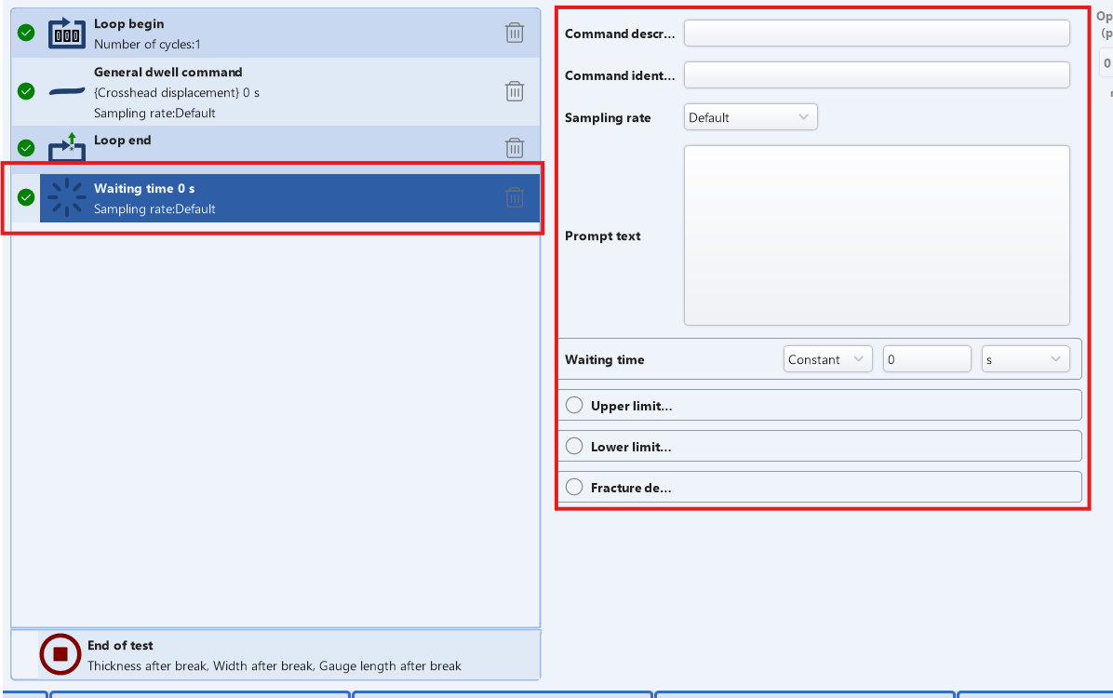
- Test end（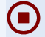）：Select the parameters that need to be recorded after the experiment is completed (the options are the input parameters previously selected in the protocol settings tab, and whether they can be modified after the experiment also depends on the checkbox in the input parameters).
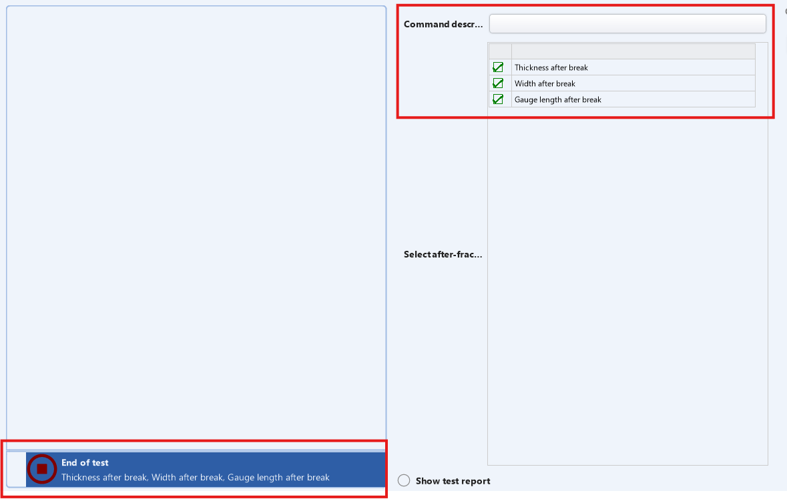

6.0 How to create a new test
TestReady software - There are 2 ways to create a new test, as shown below:
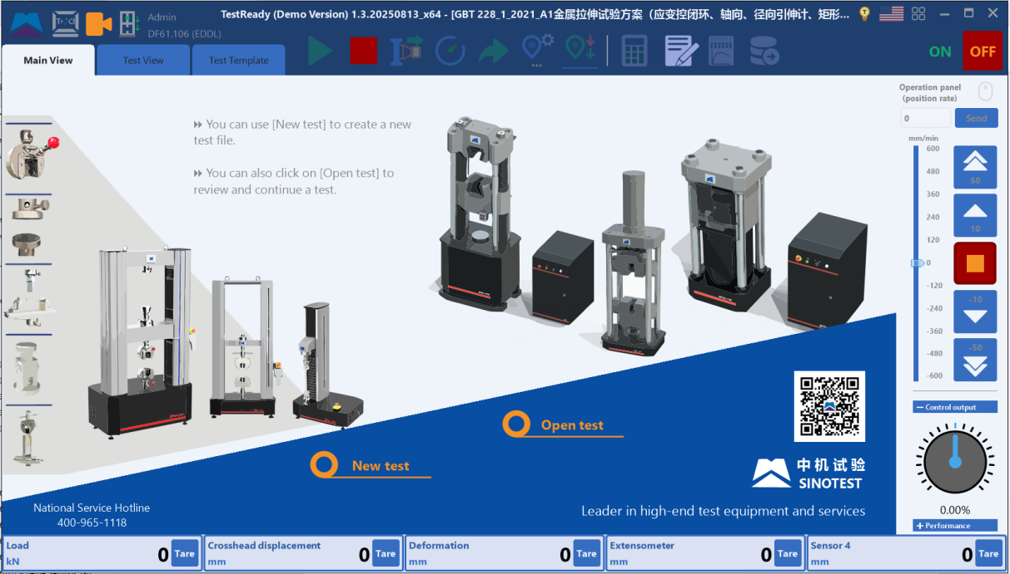
Select the software 【Main Interface】:
  - Create a new test: Create from the existing template.
  - Open a test: Add an test from the existing test that have already been conducted.

7.0 How to edit test templates
TestReady software: There are two ways to edit test templates, ①directly opening the template for editing; ② export from existing test data.

7.1.0 Open existing template directly for editing
Click on Menu, Select ‘New template’, shown as below:

Select a template that needs to be edited in the pop-up window.
Note: If editing a brand new template, the general practice is to make a copy of the existing template, change it to the new template name, and then open the "Edit Test Template" menu to edit it

7.2.0 Export from existing experimental data
- In the "Main View" interface of the software, click "Open Test Data" and select one test data to open.
- Edit the parameters of the template.
- Click Menu, Select 'Export Test Template'.

7.3.0 How to edit a new template
1. Carefully review the standards of the target template and identify which sensors are involved.
2. Select the corresponding basic templates for tension, compression, bending, torsion (extensometer, video extensometer, grating ruler, strain gauge), etc., and create a new test.
3. Basic parameters: First, modify the standard number in the basic parameters.
4. Sampling channel: mainly includes load, displacement, deformation, and sensors. Set the sensors that need to be added according to the sensor table. If it is necessary to remove or open the extensometer during the experiment, the deformation channel should be set with a combination of deformations, and displacement will be used to complete the removal or opening. Otherwise, the extensometer will track the entire process and the extensometer removal button will be gray, and removal or opening is prohibited. After opening the experimental plan for the first time or changing the setting of the deformation channel, a reminder box will pop up during the experiment, displaying what deformation sensor is currently used for the experiment and whether it is allowed to be removed midway. If it is full tracking, it is allowed to modify the deformation channel and select a specific deformation gauge (axial extensometer, axial video extensometer, axial logic extensometer [combination channel such as grating ruler]).
If Poisson's ratio needs to be calculated and radial strain gauges are not used, a transverse strain channel needs to be set up ->
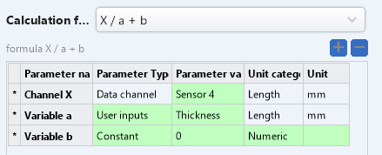
Default as radial deformation channel/specimen thickness
5. Input parameters: To view the parameters required in the standard test method, first select the input sample length, width, thickness, or diameter based on the sample category. Add the parameters required by the customer as needed. If you want to modify the input value after test, you need to choose 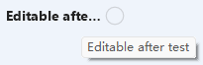;
6.Calculation parameters: Only calculations involving input parameters and constants can be set here. Modify the area formula based on the sample in the current template
-> 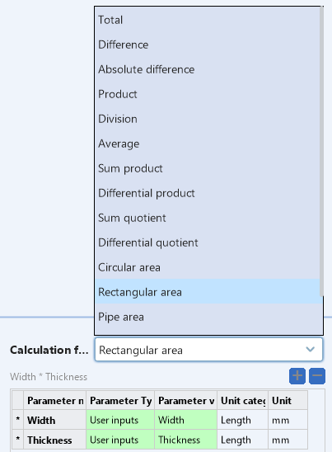
7.Output parameters: Check if custom parameters need to be added as needed. For the formula of the difference between two points, one can choose to use the starting and ending forces of the elastic segment (these two forces are indexed and can be freely selected as needed) to refer to and use a linear regression formula.
Maximum force: It is necessary to select ①formula for maximum force after yielding and ② formula for maximum channel value based on the target sample.
Post fracture elongation (automatic): For samples that cannot measure the post fracture gauge length, use this formula for post fracture elongation. Modify the gauge length in the parameters as needed: ①extensometer gauge length ②parallel length, etc.
When required for stress and strain segments, the input parameters can be modified as follows: ① Specify the starting stress of the elastic segment ② Specify the ending stress of the elastic segment ③ Specify the starting strain of the elastic segment ④ Specify the ending strain of the elastic segment
Poisson's ratio: radial strain/axial strain. Modify the parameters in the formula as needed->
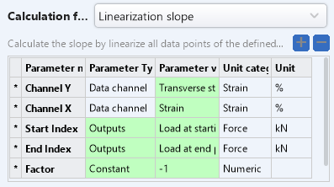
Custom para.: Click 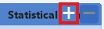-> Select Unit -> Select formula -> Select formula parameters -> Confirm to create.

8.Test process: The normal process is to input parameters ->calculate parameters ->(preload) ->reset the sensor ->start sampling ->load commands
Input sample parameters: Select the values that need to be input at this stage
Non load cell reset: Select a sensor other than the load cell (the load cell should be manually cleared before the sample is opened and after the sample is correctly installed)
Preloading: Select the required preloading form in the standard, generally using ordinary loading commands, and load at a specified speed to a force of 10N, etc.
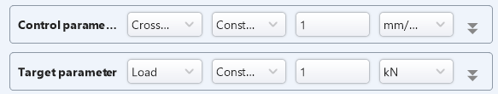
Normal loading command: Control parameters and target parameters can be arranged and selected. The general control parameter is selected as' the movement speed of the crossbeam displacement ', the target parameter is selected as' a longer section of crossbeam displacement', and finally a detection program for 'ending the experiment' is set.

9.Modify the header order according to the header sequence in the channel table.
10.Modify test report -> Double click the table to select the parameters you need-> Double click the chart to modify the horizontal and vertical coordinates. Click ‘Save’, then exit.
11. Click Menu -> Export test template -> Fill in the template name and save it.

8.0 How to set System Para.
Click on Menu and select “System Para.”

8.1.0 Equipment Para.---Host
Shown as below:
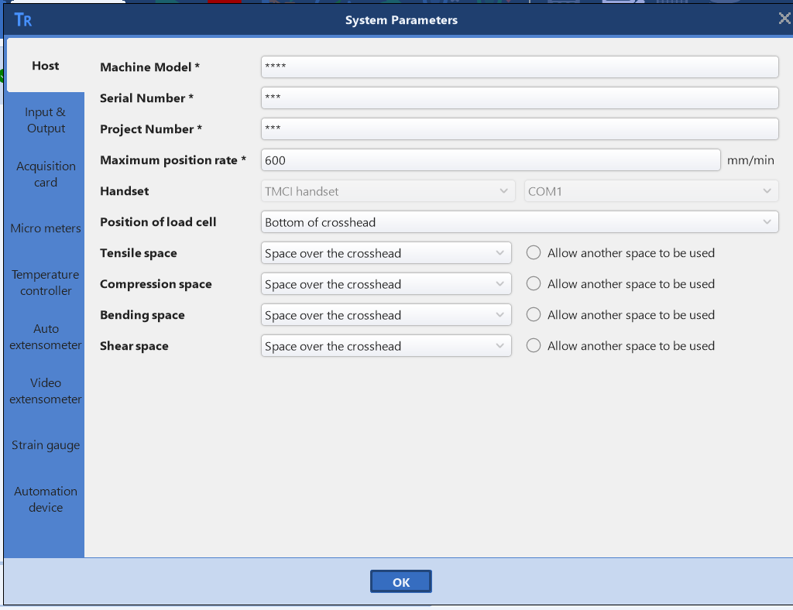

Among them, fields marked with * are mandatory:
- Equipment model: Set the model of the equipment.
- Factory number: Set the factory number of the device.
- Project Code: Set the project code.
- Maximum displacement speed: Set the maximum displacement speed of the device.
- Manual operation box: Select the manual control box and the port to be used. (If there is only one manual control box, it cannot be modified by default)
- Location of force sensor: Select the installation location of the force sensor. Above or below the crossbeam.
- Tensile testing space: Select the space for tensile testing. Above or below the crossbeam.
- Compression test space: Select the space for compression testing. Above or below the crossbeam.
- Bending test space: Select the space for the bending test. Above or below the crossbeam.
- Shear test space: Select the space for shear testing. Above or below the crossbeam.
Followings are for MGC:
- Analog channel resolution: Set the maximum resolution of the device's analog channel (such as force and extensometer).
- Enable controller force channel overload protection: If checked, the controller force channel will stop after overload, and the specific overload value will be set in the sensor management.
- Serial port channel: If the software is connected to a serial port device, check the corresponding serial port number here.
- Beam displacement resolution value: Set the minimum resolution value for beam displacement.

8.2.0 Equipment Para.---Input & Output
Shown as below:
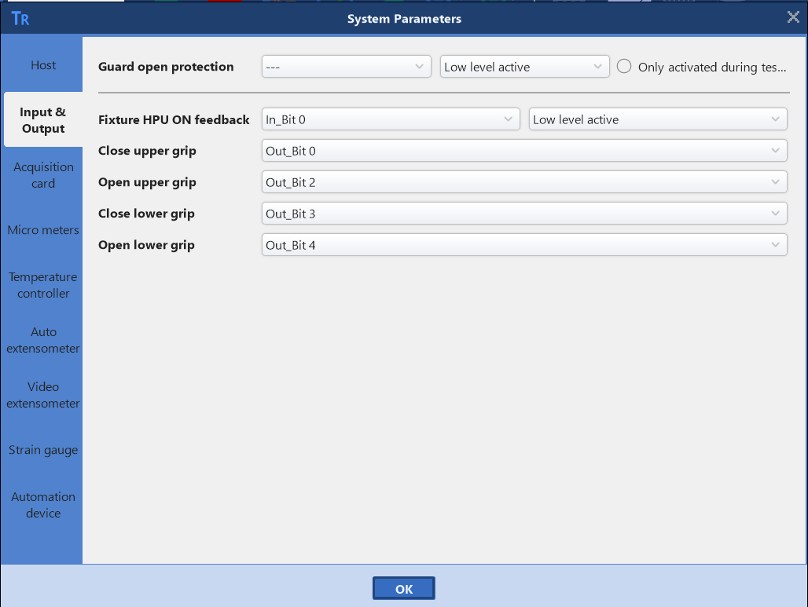
- Protective cover opening protection: Select the input signal bit corresponding to the protective cover opening protection, ① whether it is valid at high or low level, ② whether it is enabled or not during the test process.
- The opening status of the HPU of the fixture: Select the input signal bit corresponding to the fixture oil source opening status, whether it is valid at high or low level.
- Upper clamp clamping: Select the output signal position corresponding to the upper clamp clamping.
- Upper clamp release: Select the output signal position corresponding to the upper clamp release.
- Lower clamp clamping: Select the output signal position corresponding to the lower clamp clamping.
- Lower clamp release: Select the output signal bit corresponding to the lower clamp release.

8.3.0 Equipment Para.---Deformation measurement serial port chart(Micro meters)
Shown as below:
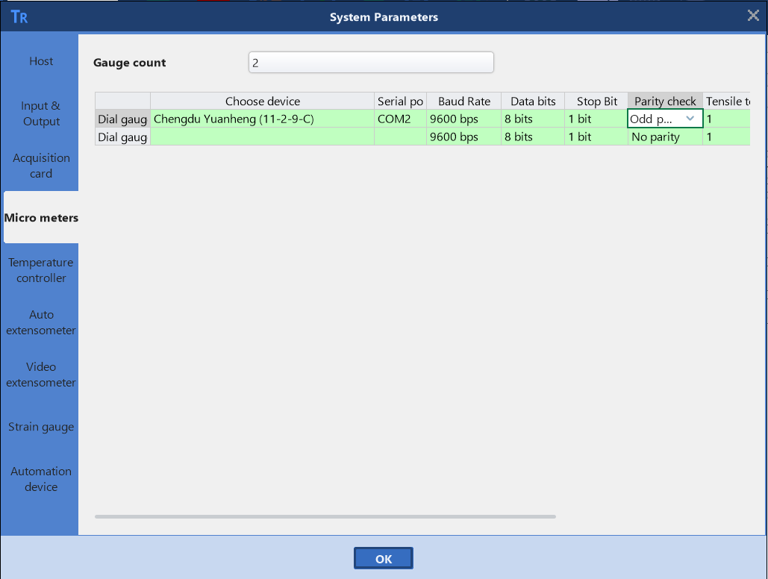

- Gauge count: Set the number of instruments below.
- Choose device: Select the device in the serial port table.
- Serial port: Select the corresponding serial port in the serial port table.
- Serial port baud rate: Select the baud rate corresponding to the serial port table.
- Serial port data bit: Select the serial port data bit corresponding to the serial port table.
- Serial stop bit: Select the serial stop bit corresponding to the serial port table.
- Serial port parity check: Select the parity check corresponding to the serial port table.
- Tensile test factor: Set the tensile test factor corresponding to the serial port table.

8.4.0 Equipment Para.---Temp Controller
Shown as below:
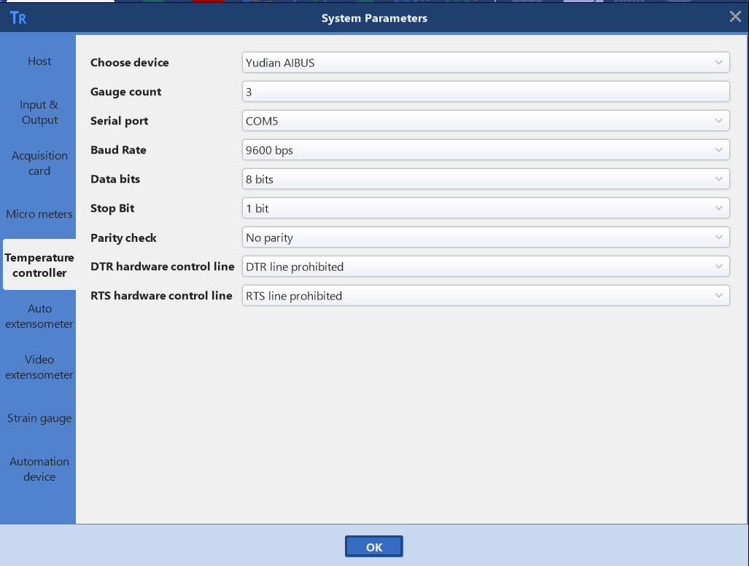

- Choose device：Select related device.
- Gauge count（Only for YUDIAN AIBUS）：Set qty.
- Temp-control range（Only for WEISHUO, as shown:
）：Set range.
- Serial port: Select the serial port number.
- Serial port baud rate: Select the serial port baud rate.
- Serial data bits: Select serial data bits (6, 7, 8 bits)
- Serial stop bit: Select the serial stop bit (1, 1.5, 2 bits)
- Serial port parity check: Select serial port parity check (none, odd, even, 0, 1 check)
- DTR hardware control line: Select the DTR hardware control line status (disable, run DTR line, allow DTR handshake)
- RTS hardware control line: Select the RTS hardware control line status (disable, run RTS line, run RTS handshake, RTS switch)

8.5.0 Equipment Para.---Auto-Extensometer
MFL 300-C/500-C/800-C, as shown below：
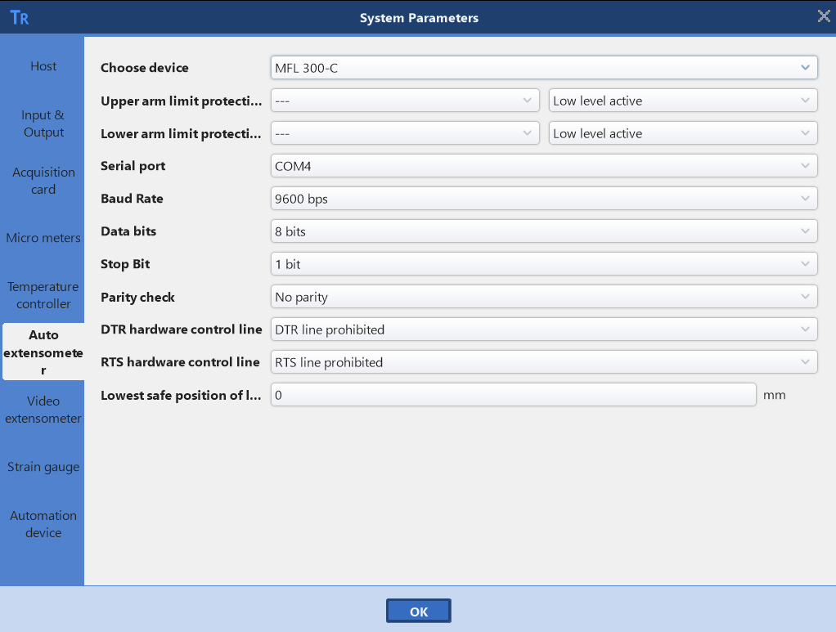

- Choose device: Select the device.
- Upper arm limit protection: Select the input signal bit corresponding to the upper arm limit protection, and choose high/low level to be effective.
- Serial port: Select the serial port number.
- Serial port baud rate: Select the serial port baud rate.
- Serial data bits: Select serial data bits (6, 7, 8 bits)
- Serial stop bit: Select the serial stop bit (1, 1.5, 2 bits)
- Serial port parity check: Select serial port parity check (none, odd, even, 0, 1 check)
- DTR hardware control line: Select the DTR hardware control line status (disable, run DTR line, allow DTR handshake)
- RTS hardware control line: Select the RTS hardware control line status (disable, run RTS line, run RTS handshake, RTS switch)

MFX500-B, shown as below:
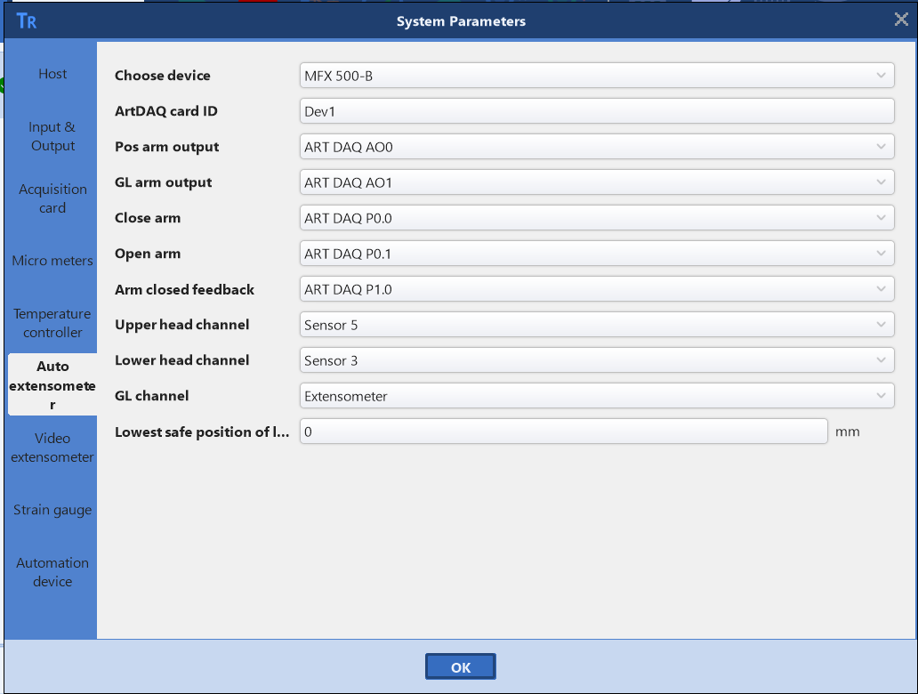

- Choose device: Select the device.
- Upper arm limit protection: Select the input signal bit corresponding to the upper arm limit protection, and choose high/low level to be effective.
- Collection card device ID: Set the collection card device ID
- Lower arm position output: Select the lower arm position output port (ART DAQ AO0/ART DAQ AO1)
- Gauge output: Select the gauge output port (ART DAQ AO0/ART DAQ AO1)
- Blade clamping: Select the blade clamping port (ART DAQ P0.0/ART DAQ P0.1)
- Blade opening: Select the blade opening port (ART DAQ P0.0/ART DAQ P0.1)
- Blade clamping feedback: Select the blade clamping feedback port (ART DAQ P1.0)
- Upper arm access channel: Select the sensor channel connected to the upper arm.
- Lower arm access channel: Select the sensor channel for lower arm access.
- Standard distance access(GL) channel: Select the sensor channel for standard distance access.
- The lowest safe position of the lower arm: When the lower fixture is completely released, the lower arm of the fully automatic extensometer runs close to the upper surface of the lower fixture, and this is the position of the lower arm.

HAE 202A/ HAE 302A, shown as below：
Select the software's communication serial port based on the computer's COM port. (The computer port in the picture is COM3, and COM3 port is also selected in the software. The subsequent settings include bit rate: 9600, serial data bit: 7, serial stop bit: 1, serial parity detection: even detection, and both are disabled.)

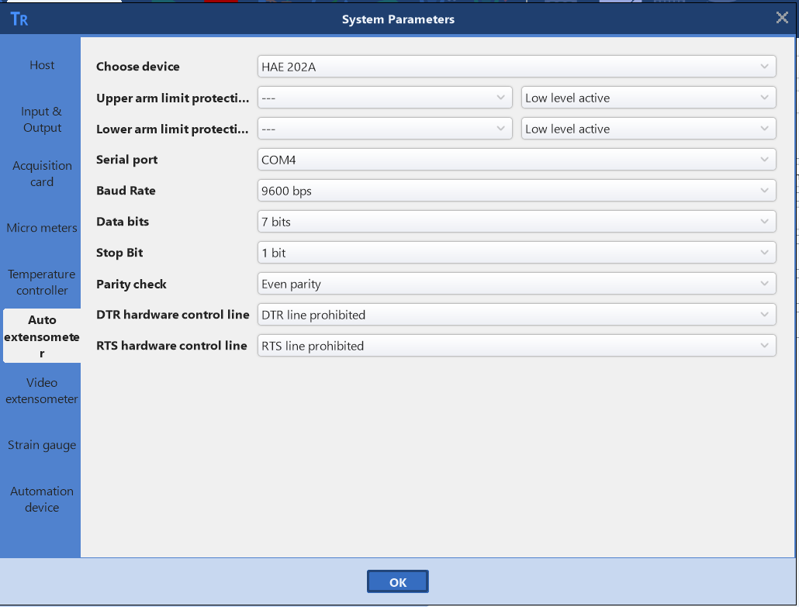

Then click ‘confirm’ to restart the software.
After restarting the software, a fully automatic extensometer icon will appear in the upper left corner, with green indicating successful communication and gray indicating unsuccessful communication. Clicking on the icon will bring up the fully automatic extensometer control interface.
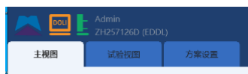

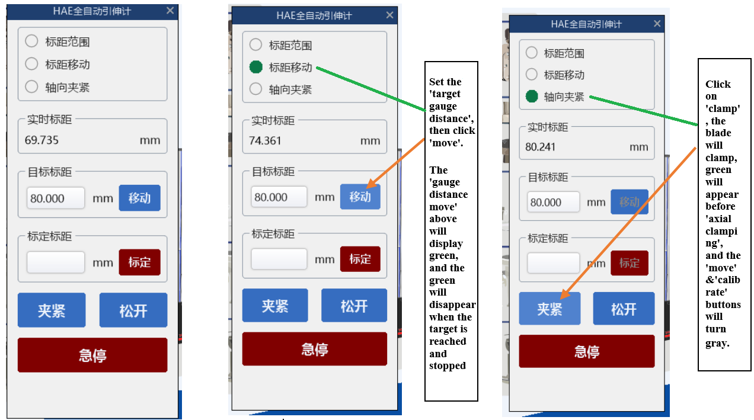

- Move: Set the target distance and click to move. Before the distance is moved, it will light up green, stop when the target value is reached, and the green light will turn off.
- Clamp: After clamping, the extensometer blade is clamped, the axial clamping is bright green, and the movement and calibration buttons turn gray. Before the test, adjust the control panel of the fully automatic extensometer first, and then add a clamping command for the fully automatic extensometer at an appropriate position in the experimental steps. The deformation channel formula uses a combination of deformation, 'fully automatic extensometer+displacement'. Set the extensometer removal point before the experiment or manually remove the extensometer during the experiment.
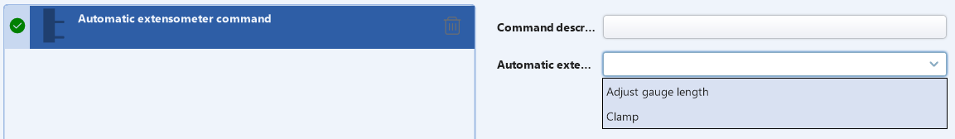

8.6.0 Equipment Para.---Video Extensometer
While LINCONST unit is adopted:

- Protocol version: Select the protocol version number (1).
While HAYTHAM unit is adopted:
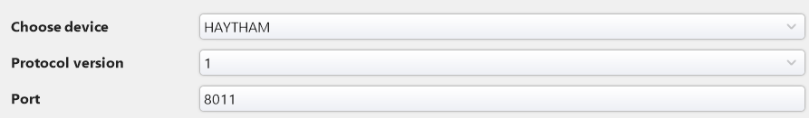

- Protocol version: Select the protocol version number (1).
- Port number: Set the port number (default 8011, do not modify without manufacturer's guidance).

8.7.0 Equipment Para.---Strain Gauge
Shown as below:
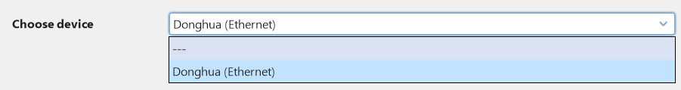
Modify the strain gauge channel in "Scheme Settings ->Basic Parameters".

9.0 How to modify software option settings

Click on Menu and select ‘Option Settings’:

The regular display is shown in the following figure:
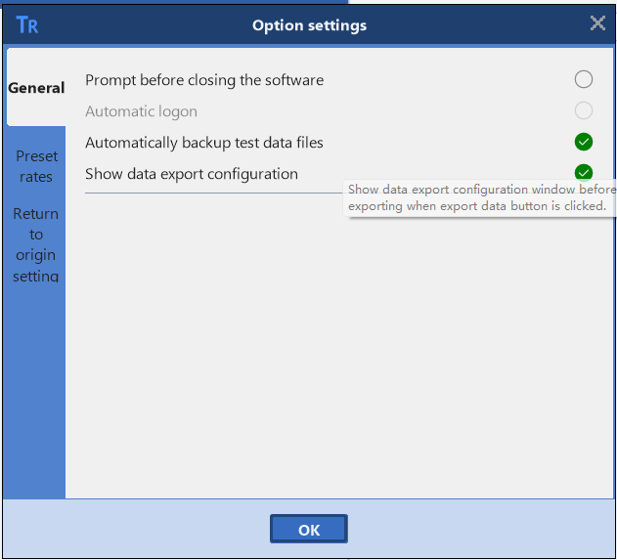

- Turn off 'prompt before closing': After selecting it, close the software directly without any prompt (can be set when closing the software for the first time).
- Automatic login: After selecting it, there is no need to enter a password and you can log in directly (which can be set when logging in for the first time).
- Automatic backup of test data files: After selecting this option, the test data files will be automatically backed up.
- Show data export configuration window: When selected, display the configuration window when exporting data.

The preset speed/rates display is shown in the following figure:
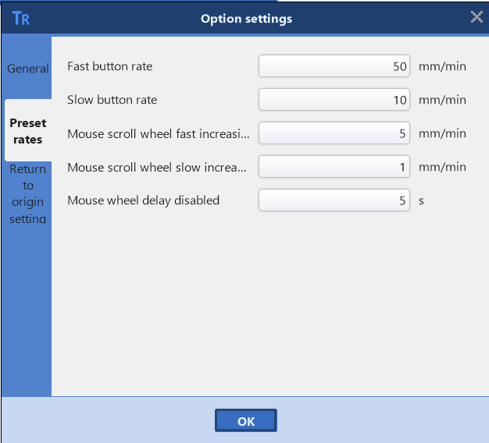

- Fast button speed: Set the speed of the quick button (default 50)
- Slow button speed: Set the speed of the slow button (default 10)
- Mouse scroll wheel fast increasing: Set the fast auto increment rate of the mouse scroll wheel (default 5)
- Mouse scroll wheel low increasing: Set the slow auto increase rate of the mouse scroll wheel (default 1)
- Calibration fast rate: Set the calibration fast rate (default 10)
- Calibrate slow speed: Set the calibrated slow speed (default 1)
- Mouse wheel calibration fast auto increasing: Set the mouse wheel calibration fast auto increment rate (default 0.5)
- Mouse wheel calibration slow auto increasing: Set the mouse wheel calibration slow auto increment rate (default 0.1)
- TMCI manual control box roller self increasing: Set the TMCI manual control box roller self increasing rate (default 5)
- Mouse wheel delay disable: Set the mouse wheel delay disable rate (default 5)

The setting for 'return to origin duration' is shown in the following figure:
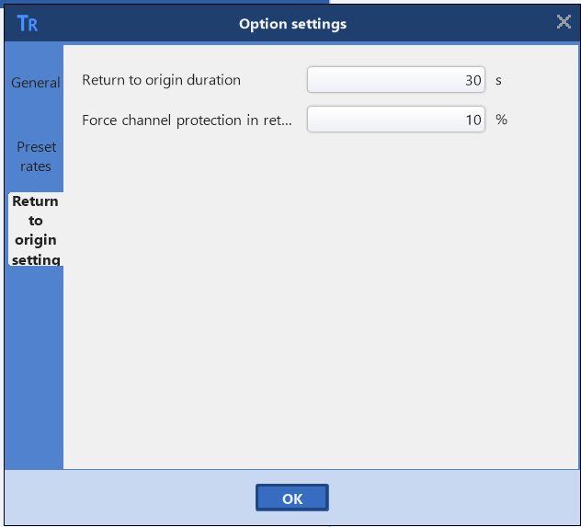

- Return time to origin: Set the return time to origin duration (default 30)
- Force channel protection during return process: Set the percentage of force channel protection during return process (default 10)

10.0 How to set sensor（MGC）
Click on menu and select ‘Sensor Management’：
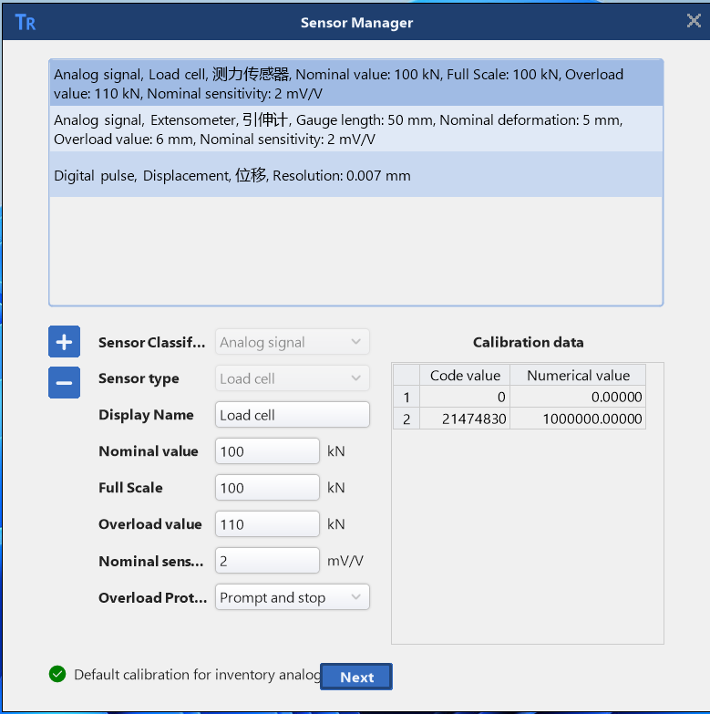
- Add: ，Click to add a sensor.
- Delete：，Delete an existing sensor.
- Confirm：，Confirm the newly added sensors.
- Cancel：，Cancel the newly added sensor.
- Classification：Set the category of the sensor: analog sensor or pulse sensor.
- Type：Set the type of sensor, such as load cell, etc.
- Display：Customize the name of the sensor.
- Nominal value：Set the usage value of the sensor (note: nominal value>=full range).
- Full range：Set the full range of the sensor.
- Overload value：Set the overload protection value for the sensor.
- Sensitivity of nominal value：Set the sensitivity of nominal value.
- Overload protection：Set the action when the sensor is overloaded.
- Direction：Direction of sensor indication.
- Calibration data：Sensor’s calibration data.

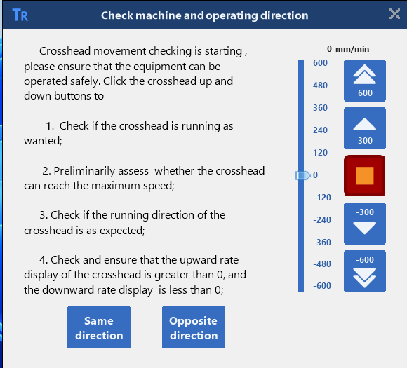

11.0 How to identify the direction of sensors (MGC)
Click on and select ‘Sensor direction recognition’, as shown in the following figure:
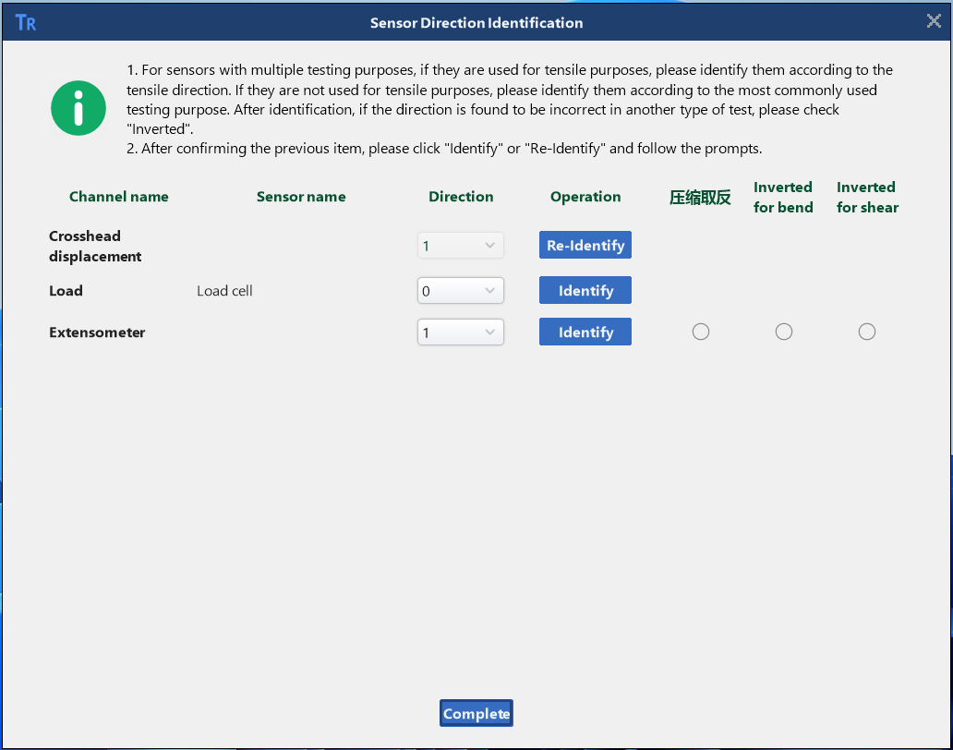
Click the "Re identify" button corresponding to the corresponding sensor and follow the prompts to operate.

12.0 How to set controller parameters (MGC)
Warning: Controller parameter settings affect the overall control operation of the device and have already been set during production. Do NOT make unauthorized changes unless necessary to avoid equipment malfunctions during operation. Please contact SINOTEST for consultation before making any changes to the settings!!

Click on and select ‘Controller parameter settings’：
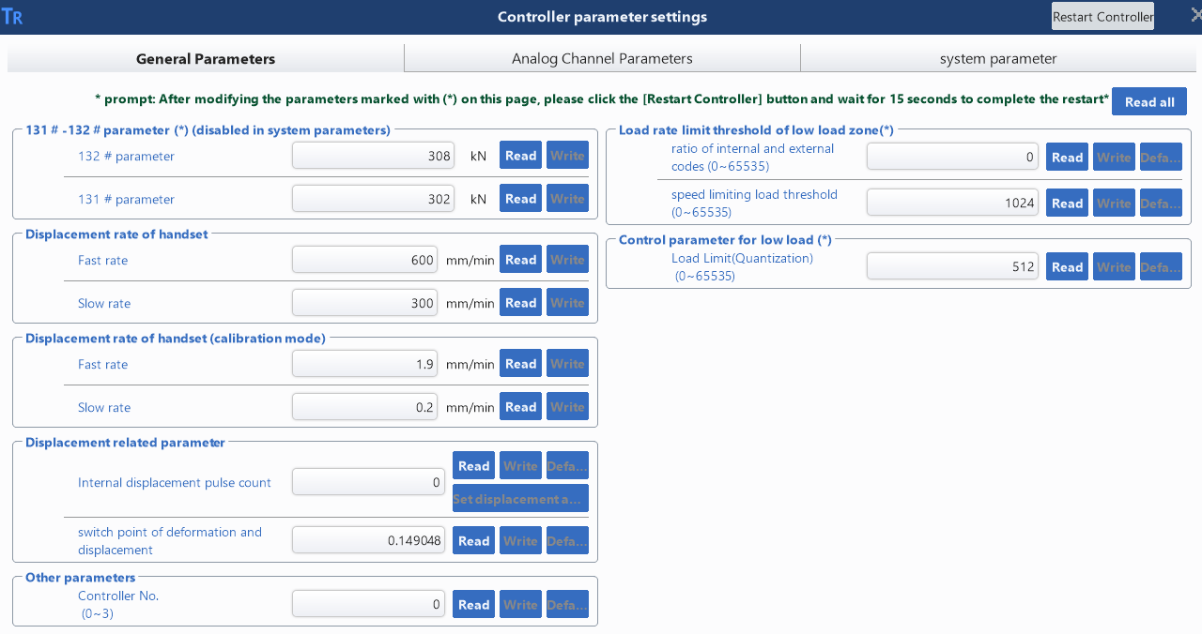
- Common para.:
- 131#-132# Para.：Internal parameters and prohibit modification.
- Displacement rate of manual control box: Set the speed of fast and slow movement of buttons on the manual control box.
- Displacement rate of manual control box (calibration mode): Set the 'fast/slow' speed of the buttons on the manual control box during 'calibration' and 'verification'.
- Displacement related parameters: Internal parameters and prohibit modification.
- Others: Internal parameters and prohibit modification.
- Threshold for speed limit and low force value zone of force control: Internal parameters and prohibit modification.
- Control parameters for low force zone: Internal parameters and prohibit modification.

- Simulate channel parameters:

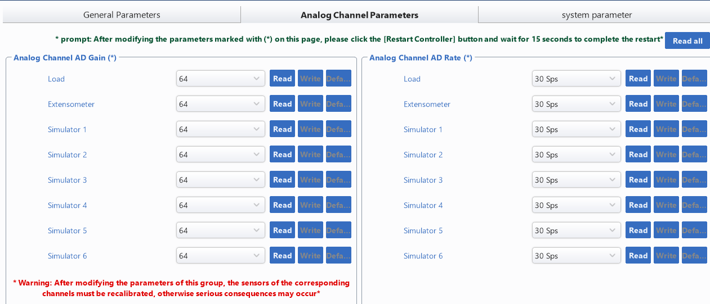
- Gain of analog channel AD: Internal parameters and prohibit modification.
- Speed of analog channel AD: The sampling frequency of the controller.
- System Para.:
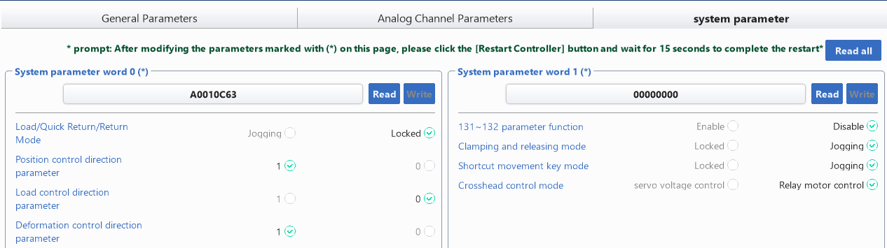
Used to set various parameters of the system. The machine has been set up at the factory and cannot be modified.

13.0 How to calibrate and verify sensors (MGC)
Click on, select ‘Calibration and Verification’：
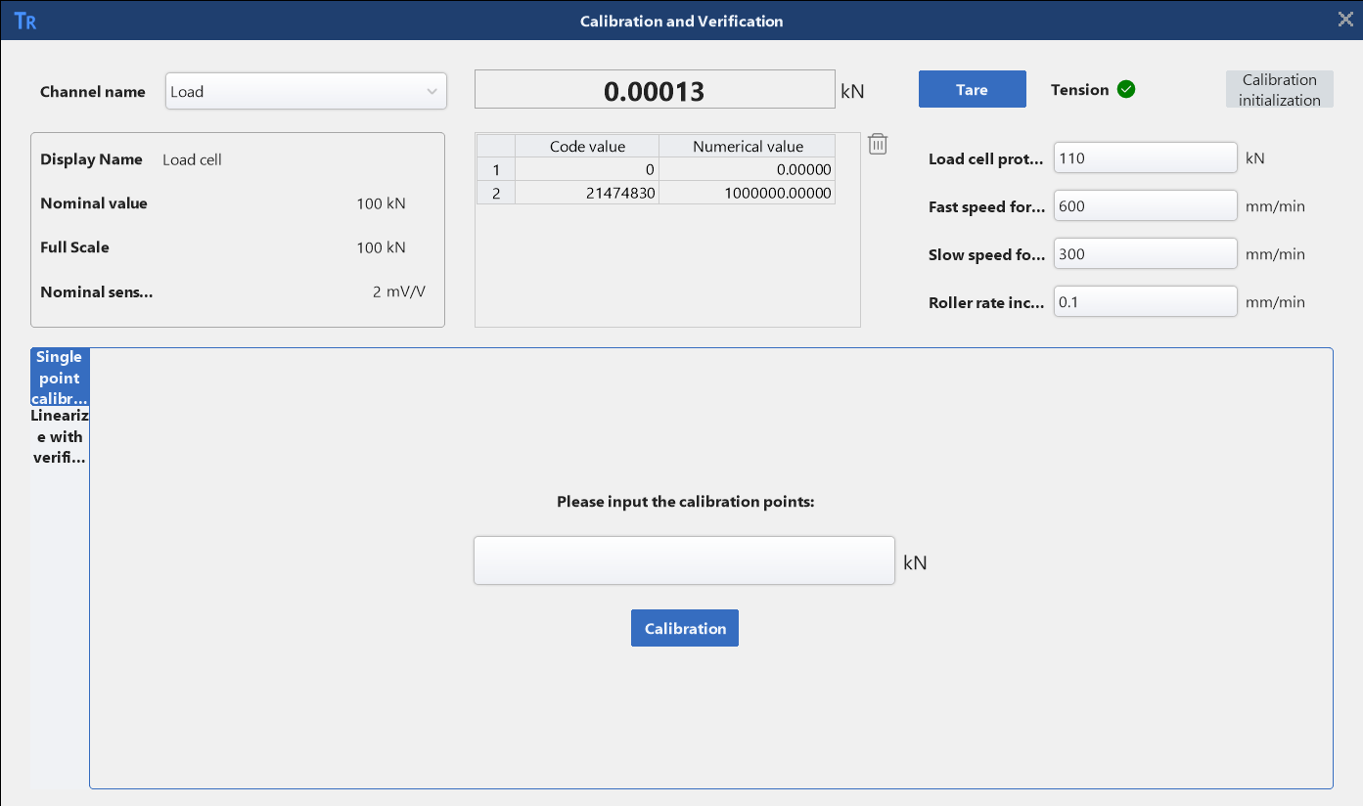

13.1.0 Calibration and verification of load cell
- Select 'Load cell' in the 'Channel Name'. Check if its nominal value, full range, and sensitivity are correct.
- Set the protection value of the load cell (usually set the protection value of a standard force gauge), the fast and slow travel speed, and the roller speed of the manual control box.
- Place the standard force gauge on the equipment and adjust the gap between the crossbeam and the sensor.
- Click on the "Single Point Calibration" tab and enter the calibration value, which is usually 50% of the full range.
- Both the force sensor and the standard force gauge are reset to zero.
- Apply force values to the standard force gauge.
- When the force value displayed on the standard force gauge reaches the set value, click the "Calibration" button to complete the calibration of the current point.
- Remove the force from the standard force gauge to 0
- Click on the "Calibration Line Repair" tab and enter the point to be calibrated.
- Click the 'Auto Load' button. When the force value displayed on the standard force gauge reaches the set calibration point, click the "Read" button, and the software will read the current force value and automatically calculate the error.
- After all the point checks are completed, check if the errors are qualified. If they are not qualified, click the "One click Line Repair" button to perform linear correction on the tested points.
- After completing the linear correction, repeat steps 8-10 until the value meets the requirements.

13.2.0 Calibration and verification of extensometer
- Select extensometer in "Channel Name". Check if the nominal value, full range, and sensitivity of the selected sensor are correct
- Install the extensometer on the extensometer calibrator.
- Click on the "Single Point Calibration" tab and enter the calibration value, which is usually 50% of the full range.
- Zero the extensometer and the extensometer calibrator to zero.
- Rotate the extensometer calibrator. When the reading of the extensometer calibrator reaches the set value, click the "Calibrate" button to complete the current point calibration.
- Return the reading of the extensometer calibrator to zero
- Click on the "Calibration Line Repair" tab, enter the point to be calibrated, and reset the extensometer to zero.
- Rotate the extensometer calibrator. When the reading of the extensometer calibrator reaches the set value, click the "Read" button, and the software will read the current extensometer value and automatically calculate the error.
- After all the point checks are completed, check if the errors are qualified. If they are not qualified, click the "One click Line Repair" button to perform linear correction on the tested points.
- After completing the linear correction, repeat steps 4-9 until the value meets the requirements.

13.3.0 Calibration and verification of displacement
- Select displacement in the "Channel Name". Check if the resolution of the selected sensor is correct.
- Place the height gauge on the testing machine and adjust the crossbeam to press onto the height gauge, aligning the zero point.
- Click on the "Single Point Calibration" tab and enter the calibration value.
- Zero displacement.
- Slowly raise and lower the crossbeam. When the reading on the height gauge reaches the set value, click the "Calibrate" button to complete the current point calibration.
- Lift the crossbeam to bring the height gauge back to zero.
- Click on the "Calibration Line Repair" tab, enter the point to be calibrated and reset the displacement to zero.
- Slowly raise and lower the crossbeam. When the reading of the height gauge reaches the set value, click the "Read" button, and the software will read the current displacement value and automatically calculate the error.
- After all the point checks are completed, check if the errors are qualified. If they are not qualified, click the "One click Line Repair" button to perform linear correction on the tested points.
- After completing the linear correction, repeat steps 6-9 until the value meets the requirements.

14.0 How to use the control debugger (MGC)
The control debugger is mainly used to check the accuracy of the control and view the running status of the device.
Click on, select ‘Control debugger’：
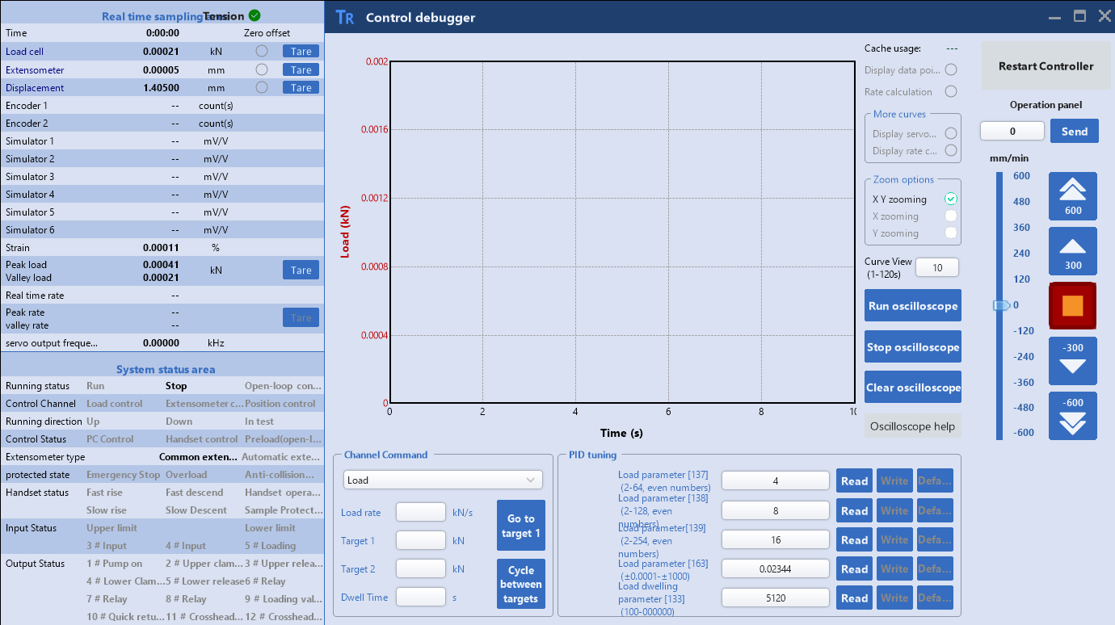

- Real time sampling area: Display real-time sampling values.
- System status area: displays the current status of the system and helps analyze equipment issues.
- Display sampling points: After selecting, display the sampled data points on the curve
- Rate calculation: After selecting, you can choose two points on the curve to calculate the current control speed
- Extended Curve Options: Display servo or rate curves as needed
- Scaling options: Set options for curve scaling up or down
- Curve window: time curve interval displayed on the x-axis
- Oscilloscope operation: Click to display the curve
- Oscilloscope stop: After clicking, the curve stops displaying
- Oscilloscope screen clearing: Delete current curve
- Normal command: Set the loading control steps to verify the accuracy of controls (such as force).
- Parameter tuning: When the control is not good, this parameter can be adjusted to adjust the control.

15.0 FAQ
Q: How to export data as XLSX or CSV files?
A:->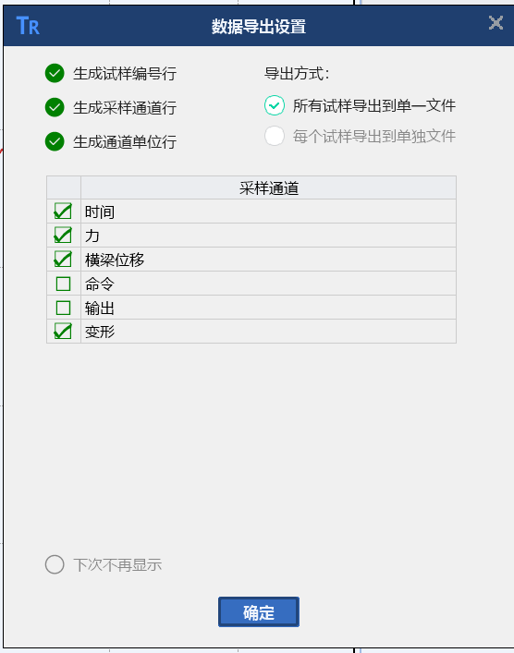->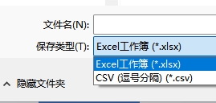。

Q: How to export a template to a Word document? What should I do if there are problems during the export process?

A:->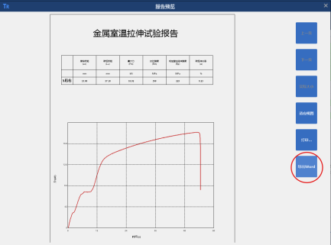
Office Version 2013+needs to be installed.
There may be WPS software self starting on the computer, or an unknown conflict in word.exe in the background.

How to disable self startup:
1.
Through the Task Manager: Press the shortcut key "Ctrl+Shift+Esc" to open the Task Manager, switch to the "Startup" tab, and the list will display all programs that start automatically when turned on. Right click on the startup option you want to disable and select 'Disable'.

2.
Through system configuration: Press the "Win+R" key to open the "Run" window, enter "msconfig" and press enter, the "System Configuration" window will pop up, select the "Startup" tab, uncheck the programs that do not require startup, and click "OK" to save the settings.

3.
Through system settings: click on the "Start" menu, select "Settings", enter the "Applications" option, and then click "Start". In the list of startup programs, turn off the unnecessary self startup program switch.
Close all Word.exe (or Wps.exe if available) in the background.

4.
Through the Task Manager: Press the shortcut key "Ctrl+Shift+Esc" to open the Task Manager, switch to the "Details" tab, and close all Word.exe (or Wps.exe if available) in the background

16.0 Appendix
Manual for Fixed Channel Setting Values:
 | Controller related para. |  | Test Ready related para.
Sensor 0 | Displacement | Sensor 0 | Displacement
Sensor 1 | Load | Sensor 1 | Force
Sensor 2 | Axial Extensometer | Sensor 2 | Axial Extensometer
Sensor 3 | Reserved for DOLi/ TMCi hand controller | Sensor 3 | Default as not used
Sensor 4 | Radial extensometer | Sensor 4 | Radial extensometer
Sensor 5 | Grating sensor 1/ Large deformation Extensomter 1/ Deflectometer 1 | Sensor 5 | Grating sensor 1/ Large deformation Extensomter 1/ Deflectometer 1
Sensor 6 | Grating sensor 2/ Large deformation Extensomter 2 | Sensor 6 | Grating sensor 2/ Large deformation Extensomter 2
Sensor 7 | Grating sensor 3 | Sensor 7 | Grating sensor 3
Sensor 8 | Grating sensor 4 | Sensor 8 | Grating sensor 4
Sensor 9 | Calculation channel | Sensor 9 | Calculation channel

1. Sensor 2 is an Axial extensometer
2. Sensor 3: Doli controller is considered as manual control box, then TMCI sensor 3 is not used by default.
3. Sensor 4 is a Radial extensometer
4. When using large deformation, grating sensor , and deflectometer, please use Sensor 5/6/7/8 in sequence
5. Sensor 9 is a simulation calculation channel for large deformation sensor, grating sensor, etc. (For example: 5+6)

The template in TestReady corresponds to the upper part. In the deformation channel, modify the obtained channel according to the requirements as follows:
- Sensor 0 displacement
- Sensor 2 Axial extensometer
- Sensor 5 Deflectometer
- Sensor 9 Calculation Channel
- Axial video Extensometer
The data of the video extensometer and strain gauge are transmitted through software, and the channel appears after selecting the corresponding model. The strain gauge selects the number of channels and corresponding channels as needed.

Heading list: Load, Displacement, Deformation, Axial extensometer, Radial extensometer, Large deformation extensometer, Video extensometer-axial, Video extensometer-radial, Axial strain, Radial strain, Deflectometer

